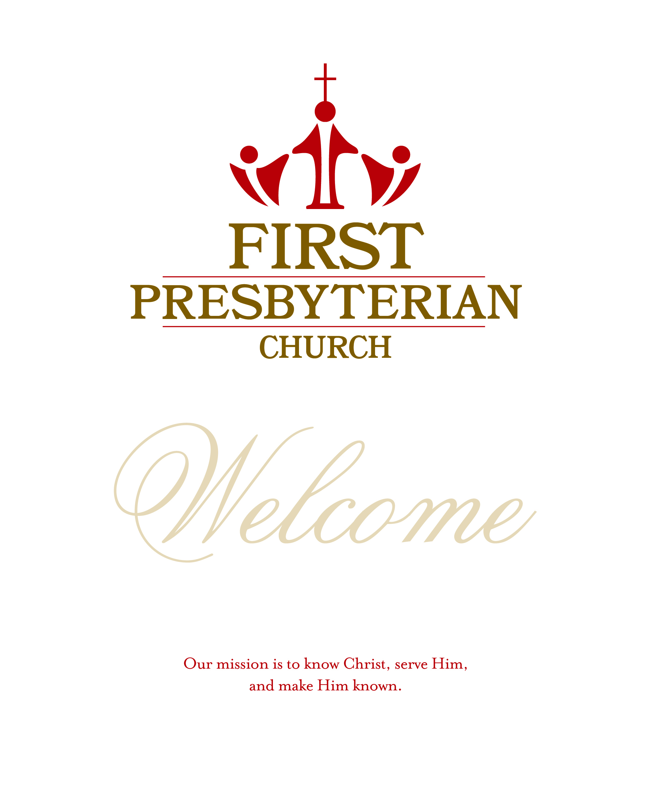
Order of Worship 11:00 a.m. April 25, 2021
~ Gathering before the Word ~
Welcome Pastor Heath Burchett
Prelude This Is The Day Traditional
Toby Caskey, piano

Chimes of the Trinity
*Call to Worship Psalm 116
Leader: I love the Lord, because God has heard my voice and my supplications.
People: Because You inclined Your ear to me, therefore I will call on You as long as I live.
Leader: I will lift up the cup of salvation and call on the name of the Lord.
People: I will pay my vows to the Lord in the presence of all God’s people.
Leader: Let us worship God!

*Hymn of Praise No. 579 Immortal, Invisible, God Only Wise ST.DENIO
*Prayer of Praise & Adoration
UNISON: We enter Your courts with praise, O God; we come into Your house with thanksgiving. In Christ You give us the cup of Salvation; in Him we receive the bread of life. To You indeed our vows are to be made; You shall hear our confession of faith. So be with us now as we gather and be pleased with the homage we bring. Amen.
Prayers of the People and the Lord's Prayer
Our Father who art in heaven, hallowed be Thy name. Thy kingdom come, Thy will be done, on earth as it is in heaven. Give us this day our daily bread, and forgive us our debts, as we forgive our debtors; and lead us not into temptation but deliver us from evil. For Thine is the kingdom and the power and the glory, forever. Amen.
~ Proclaiming the Word of God ~
10 Cents A Meal Amelia Caskey
*Hymn of Preparation No. 264 Lift High The Cross CRUCIFER
Sermon “The Power Of Prayer” Pastor Heath Burchett
Scripture Reading Colossians 4:2-6

~ Responding to the Word of God ~
*Affirmation of Faith Apostle’s Creed
I believe in God the Father Almighty, Maker of heaven and earth;
and in Jesus Christ His only Son our Lord; who was conceived by the Holy Ghost, born of the virgin Mary, suffered under Pontius Pilate, was crucified,
dead, and buried; He descended into hell; the third day He rose again from the dead; He ascended into heaven, and sitteth on the right hand of God the Father Almighty; from thence He shall come to judge the quick and the dead.
I believe in the Holy Ghost; the holy catholic Church; the communion of saints; the forgiveness of sins; the resurrection of the body; and the life everlasting.

*Hymn of Commitment No. 897 What A Friend We Have In Jesus CONVERSE
*Benediction

Postlude Short Festal Postlude Otis

Acolyte: Noah Walker

*All who are able please stand
CCLI# 221136

If you would like to contribute flowers for worship, please see the sign-up poster on the bulletin board just outside the church office. The cost for an arrangement is $56.
www.firstpresb.org
201 Vance Street
Kannapolis NC 28081-4383
Phone - 704-938-4623
The Session
Jeff Barnhardt, Clerk of Session
Class of 2021
Jeff Barnhardt
Frank Gibson
Phil McLain
Class of 2022
Debbie McDaniel
Gip Rumple

Class of 2023
Dave Argabrite
Renee Goodnight
Ryan Walker
Church Staff
Heath Burchett
Supply Pastor
David Hamilton
Director of Music
Michelle Walker
Director of Children’s Ministries
Terri Pruett
Bookkeeper/Videographer
Angela Simpson
Office Manger
Kay Yates
Organist
Irene Davis
Nursery Director

Sermon Notes:
Passage Colossians 4:2-6

Prayer Concerns
New Prayer requests will be placed
in the bulletin for two weeks.
Please help us keep Prayer Concerns current with
weekly updates emailed to firstpresb@firstpresb.org.
HOMEBOUND
Special Church Member
of the Week

Mrs. Peggy Deal Barnhardt
507 Queens Gate Dr.
Kannapolis NC 28083-4056

Send a card, make a visit or a call, or offer a prayer. All to say, "God loves you and the church cares about you."
Peggy Barnhardt - at Morningside
Iris Efird
Betty Overcash - at
Elmcroft in Salisbury
Barbara Wise
Loretta Young - at Five Oaks
MEMBERS
Paul Barnhardt - Health concerns
Debby Baker – Cancer
Jean Roberts-
(in ICU at Atrium Health with breathing issues)

FAMILY & FRIENDS OF MEMBERS
Laura Hunter- Friend of Dawn Cavin (Elderly, dealing with health issues)
Shari Blackman- neighbor to the Strickers (Struggling to recover from a heart & lung transplant.)
Cindy Fisher- Mother of Lucinda Stewart (At Transitional of Kannapolis.)
Susan Gibson- Daughter- in -Law of Frank Gibson (Responding well to cancer treatments.)
Krystle Tacia- friend of Chariti Lowder (Recovering from last surgery, breast cancer survivor.)
Roxanne Debord - daughter of Tony & Judy Hunter (has finished radiation and appreciates continued prayers.)
Wade & Mary Nunnery- Parents of Karen Pless (Father has Sundowners Syndrome & her mother is primary caregiver and physically needs strength & relief from her own pain)
Barbara Coffey- friend of Judy Hunter (Cancer treatment)
Lori Holder - daughter of Sam McAllister (MS)
Prayer request? Please write it down on the blue pew prayer card, & place in the offering plate.

Announcements:
Please join us in packing Law Enforcement Appreciation Bags! To show our support of the Kannapolis Police Department, we are again asking our church members to assemble a bag or bags of goodies! Bags may be placed on the back table in the Fellowship Hall now through Sunday, May 2nd. We will deliver the bags the afternoon of Wednesday, May 12th. To 'adopt' a bag, please sign up HERE: https://www.signupgenius.com/go/70A0A4AABAC2EA1FB6-lawenforcement (password: 2serve) Officer Bags should include: black or blue ink pens, small memo pad, travel size facial tissue, small hand sanitizer, lip balm, auto air freshener(s), hand wipes, small bottles of car upholstery and/or or glass cleaner, and individually-wrapped gum and hard candies. Dispatcher bags should include: black or blue ink pens, travel size facial tissue, small hand sanitizer, lip balm, hand wipes, tea bags, honey sticks, gum, and candy. See Debbie McDaniel or Michelle Walker for more information.
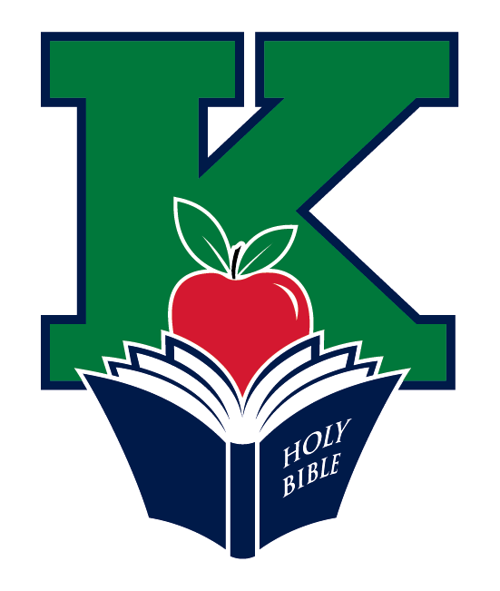 Mark your calendars for the Kannapolis Bible Teaching Association 2021 Fundraising Campaign! Between May 1 and May 15, you may make donations to help fund Bible History Teachers in the Kannapolis City School System and cover administrative costs of the Association. Contributions may be given at www.kbta.org, or mailed to: KBTA, PO Box 987, Kannapolis, NC 28082. Thank you for your faithful support of this important ministry!

Men’s Devotional: Men’s Devotional Saturday, May 8, 2021will meet in the Fellowship Hall
at 8:30am for Devotional. Please let Dave know if you are planning to attend the devotional so we can plan accordingly. Picnic table assembly will be in June as a workday for all men.
Circle of Women will meet on Wednesday, May 12, at 2:00pm in the Fellowship Hall. All women are invited. Covid protocol will be followed.
Volunteers needed for our Worship Production Team! We need volunteers who are willing to learn and give their time on Sunday morning and other special worship services. If you would like to learn how to operate the sound system, streaming software, and/or camera so we can bring our worship services to those at home via YouTube, let us know by calling the church office, or emailing David at DavidHamilton@firstpersb.org or TerriPruett@firstpresb.org
The Red Cross will be holding a blood drive in our Fellowship Hall on Monday, May 10th. Blood drive hours are from 2:00 to 6:30 PM.
The Hamiltons:
David and Amy Hamilton were commissioned as missionaries by Greater Europe Mission in 2020. As soon as they reach their support goal, they and their four children will move to Frankfurt, Germany. As a result of the refugee crisis, many Muslim immigrants in Frankfurt are hearing the gospel for the first time and hearts are being regenerated. David and Amy will work with a network of evangelical churches and ministries to disciple new converts, train them to be leaders in the church, and teach them to make disciples. For more information, please check the vestibule for The Hamilton Road newsletter and information about missions in Frankfurt.

EVENTS THIS WEEK:

Today: 10:00 am Adult Sunday School continues in the Fellowship Hall at 10am. Frank Gibson, Leader. (For Zoom link contact Michelle Walker)
-Children/Youth Sunday School on Choir Hall
-11:00am - Worship Service in Sanctuary and on YouTube
-12:00-CE Team Meeting in Sanctuary
- Confirmation Class in Fellowship Hall
Monday: 6:00pm - Saltshakers (virtual; contact Sharon Cranford)
Tuesday: 12:00pm - NA in Fellowship Hall
Wednesday: 7:00pm - Elementary Wednesday Night Life (virtual - contact Michelle Walker)
Thursday: 10:30am - "Bad Girls" Bible Study
-12:00pm - NA in Fellowship Hall
Friday:
Saturday:
Sunday: 10:00am - Adult Sunday School in Fellowship Hall:
Ron Lisenby, Leader
- Children/Youth Sunday School on Choir Hall
-11:00am -Worship in the Sanctuary and on YouTube

