Central Life
Central Presbyterian Church
April 6, 2022

Reflections from a Rocking Chair
This is a story about a pawn shop clerk, a police detective and a pastor and the finding of a guitar, and how God’s fingerprints and work became evident. Most of you heard that the guitar I use in Worship was stolen on February 12 from Central Hall. There was a door left unlocked which allowed access to that room. Here is a wonderful story of many people involved in its return.
On that Saturday, after I talked to the police and made a report, I called several pawn shops in the area, asking the clerk to keep an eye out for my guitar. I spent several days driving from shop to shop in the tri-cities looking at their inventory just to see if I found it. But nothing.
On Tuesday, March 15, as a part of my daily devotional time, I asked God to help me release the concern and worry about the guitar as I could not keep searching Ebay and Facebook Marketplace for it, hoping it would turn up. Then I headed to the church for our monthly staff meeting.
After the staff meeting was concluded, Detective Mark Edwards came to the church to say that the guitar had been found and I needed to identify it as being mine. He told me that as a part of his morning devotional time, he had prayed that this would be the day to find the guitar. He serves a local small church as a pastor and understood what it meant to have it taken. That morning when he got to work, a police bulletin came across his desk of a pawn ticket for a guitar that had been retrieved from someone taken into custody. He said that he knew that was my case. After waiting for 2 hours for a Tennessee police officer to accompany him to the pawn shop, he took pictures of it and showed me what he had found. Yes, it was my guitar. The capo and the picks were still on it as well as the strap with all my memorabilia pins. I could not believe it had been found and in great condition.
Detective Edwards said that I had to call the pawn shop and talk to the lady there and confirm that the guitar was mine. I called, and after identifying myself, the lady said that she wanted to tell me her side of the story. On that Saturday (Feb 12) when I called to ask her to keep an eye out for it, she said that she was actually taking it into possession as a pawned item. But legally she could not tell me she had it. But she instructed me to get the police involved. She said that as I came in her shop several times, she wanted to pass me a note telling me that she had my guitar, but could not do that according to the law. So she prayed daily that the connection would be made and the guitar would be returned. She said that when the two officers came in her shop that day, she knew why they were there. She had prayed that morning that God would work on getting this guitar back to me. She was so excited about how everything worked out and that on April 13, I would have it back in my possession.
What is interesting is all the people involved in this event, and how we were all praying for God’s guidance and help. I needed help to let go of the worry and concern. Detective Edwards wanted it to be located somehow. The pawn shop lady knew what she had and asked God to open the doors to have the guitar returned to me. All of the pieces of the story come together so well, but while in the middle of the story, it was not easy to see any of the connections working.
But now in looking back over the last 6 weeks, and knowing the rest of the story, it is easy to see the hand of God at work bringing us all together. I do thank everyone for your concern and for your searching for the guitar too. One more thing, I ask you to join me in praying for the man who took it. He is in jail for other break-ins in Bristol, but I know that God can work good in his life as well offer him transformation. Please add to your prayers Danny Charles Wilburn, Jr. that God will work in him in this time.
Grace and peace,
Ann

Congregational Joys and Concerns:
At Home: Bob and Becky Ingram; Bessie Kitts
At Brookdale: Carol Duhaime, Jean Thomas, and Mary Kay English
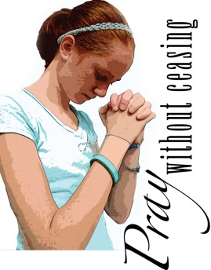
At Dominion Senior Care: Linda Wise
At Oakmont: Allen Vance

Pastoral Concerns:
Lynn Gilbert’s mother who is dealing with serious health issues;
Phyllis Morris as she is having some tests;
Ed Updyke as he continues to recover;
Ed Whitehead as he is having some tests done in Roanoke.

Continued Prayers for:
Randy Broyles, Travis Campbell, Bob and Becky Ingram, Jim & Joan Keith, Mark McCord, Don Miller, Alice Owenby, Allen & Retta Vance, Linda Wise, Rev. Michael Weller.

Prayers for Family members:
Beverly Bosch (Randy and Phyllis Morris’ daughter); Orin Callison, III, son of Peggy Callison; Cathy White’s father, Roy.

Please call the church office (276-669-3157) with any pastoral concerns, and please feel free to contact Ann Aichinger through email, Facebook, or by phone.

Memorials:
To the General Fund in memory of Dora Webb, given my Mary Moffatt.
To the Memorial Fund in memory of Dora Webb, given by Scot and Connie Bullock.

We extend our Christian Sympathy to:
“Blessed are those who die in the Lord; they will rest from their labors and their deeds will follow them.”
Revelation 14:13
“Blessed are those who die in the Lord; they will rest from their labors and their deeds will follow them.”
Revelation 14:13
“Blessed are those who die in the Lord; they will rest from their labors and their deeds will follow them.”
Revelation 14:13
We extend our deepest sympathy to Doris Hall and to the family and friends of Dora Webb who died on March 21, 2022. The Celebration of Dora’s life was held on March 25 at the church.

Congratulations to:
Linda and Eugene Waldron in the birth of a new grandson, Bennett Reece Waldron, born on March 22, 2022, 6 lbs., 18 inches long. Happy parents are Collin and Leann Waldron and big sister is Amelia.

Zach Baker who is a new uncle. His nephew Rhett was born on March 28, 2022 to his sister Sarah and her husband Brett Ware in West Virginia. He was 8 pounds, 20 inches. All are doing well.

Easter Flowers
The Worship Committee is offering you a chance to place beautiful blooming plants in the Sanctuary and Central Hall in celebration of Easter. This year we will have large white hydrangeas in pots. Donations of $30.00 can be made for a plant, or in any amount to the Flower Fund toward plants that can be put in the church yard. As usual, donations can also be made to Bristol Faith in Action in lieu of the flowers. All gifts given in memory or honor of family and friends will be listed in the Easter bulletin. Forms are available on the tables in the church entry as well as in the office. Deadline is by April 12.

Giving of Tithes and Offerings
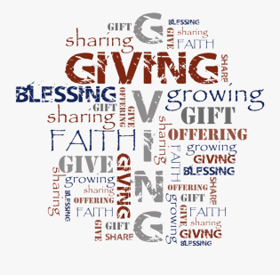
The leadership of the church is very appreciative of the continued financial giving by our members and friends. You are encouraged to continue to share your gifts and money with the church. All gifts are greatly appreciated. The church continues with ministries in caring for those in need and supporting those agencies and groups who offer assistance to those in need. Please give your tithes, offerings, and contributions by:
In Person Worship: Placing it in the plate or box at one of the doors.
Mail: Central Presbyterian, 331 Euclid Ave., Bristol, VA 24201
Online: CentralPresBristol.org and go to the Give Online tab
Text: CentralPres (Capital C and P no spaces) to 73256

Pinwheels for Peace
Throughout our world and in our lives, there is so little peace. Yet Jesus offers us the gift of peace. As disciples of Jesus, we are encouraged to pray for God’s peace to come to our world. In today’s world, peace needs to become more than just a word. The Evangelism Committee is offering Pinwheels for Peace where we can see our prayers being lifted up in the wind. Imagine …..whirled peace!
Peace doesn’t necessarily have to be associated with the conflict of war; it can be related to violence or intolerance in our daily lives, and can be a request for peace of mind. To each of us, peace takes on a different meaning for different experiences..
A pinwheel is a childhood symbol; it reminds us of a time when things were simple, joyful, peaceful. The youth groups have worked on Pinwheels for peace for Ukraine (using the colors of the Ukrainian flag).
We have about 200 plastic pinwheels of all colors. As a part of our Easter celebration, everyone is invited to write prayers for peace on the plastic pinwheels. Then the pinwheels will be placed in the church yard as an art installation where our prayers are visible to all. Let us pray together for World Peace---for the Peace of Christ to come into our world.

New Windows being installed
The Property committee has been hard at work to be ready for new windows to be installed in the Education building of the church. This will begin on April 11, which coincides with Apple Academy’s Spring Break. This will allow those rooms to be worked on first and completed within the week. Window World will be installing them and the windows will be much easier to use and have better insulation. Please be mindful of the construction going on over the next couple of weeks as this project is completed.

Sermons
April 10 Palm/Passion Sunday Luke 22:14-23:56
April 17 Easter Joy Luke 24:1-12
April 24 Guest preacher: Dr. Brian Alderman
May 1 Guest preacher: Dr. Brian Alderman

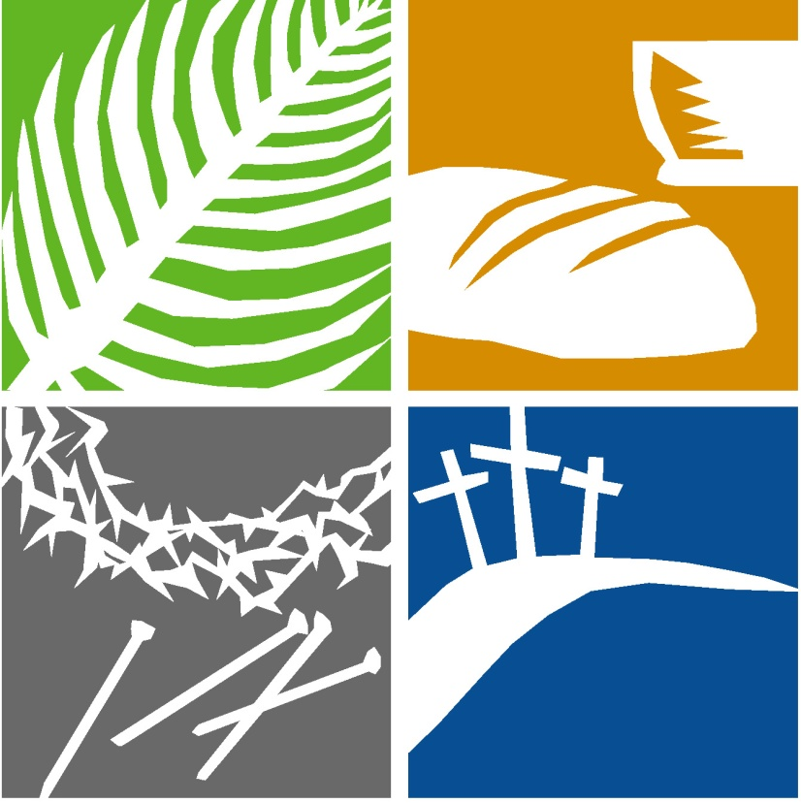
HOLY WEEK
This year, we are looking forward to having in-person Holy Week services. You are invited to join us as we begin with the journey into Jerusalem and conclude with the Empty Tomb on Easter Sunday.

Sunday, April 10: Palm/Passion Sunday Worship (9 a.m. and 11 a.m.) Reading the Passion story from the Gospel of Luke

Thursday, April 14: Maundy Thursday Service at 7 p.m. in Central Hall We will share in the Lord’s Supper and then have a Tenebrae service.

Friday, April 15: Good Friday Service at 12 Noon in the Sanctuary

Easter Sunday, April 17: Worship at 9 a.m. and 11 a.m. We will have Easter Egg Hunts for the children during the Children’s Church time at both services.

Wednesday Evening Dinners and Programs (April 20-May 18)
Because our Lenten dinners and programs have been a success and we have had great turnout, we will continue them for five more weeks. The following is the schedule and we hope you can join us for fellowship and good food. Dinner will be served at 5:30 and then we will have a program for all ages starting at 6:10 and will be finished by 7 p.m. Please be sure to sign up for dinners so we know how to plan the food.

April 20: Who are You? A chance to get to know each other better
April 27: Game Night---bring your favorite game or join in on a game
May 4: Stump the Pastor (you can ask any question)
May 11: Game Night---bring your favorite game or join in on a game
May 18: Central Talent Show – Everyone is welcome to be a part of the show and share your talent or skill
Christian Education Summer Survey

The Christian Education Committee wants your input as to what you would be willing to participate in over the next few months. There is a survey asking if you would participate in Wednesday evenings though May 18. Then there is a request to help us plan for Vacation Bible School on the format as well as possible dates. Another option being considered is to offer Movie Nights in the summer where there will be a movie for adults and a movie for children (in the theater room).
The survey is available on the entry table and will be emailed out and we ask that you return it as soon as possible so we can make plans.

New Members:
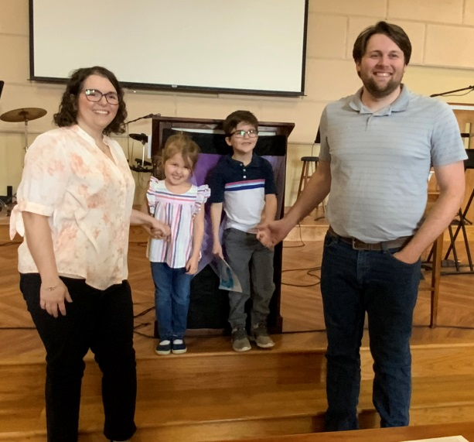
We welcome into our membership Matthew and Valerie Coker and their children Lizzy (age 3) and William (age 5). They come to us by Reaffirmation of Faith. Please add their information to your directory and welcome them as a part of our church.

Matthew and Valerie Coker
William and Lizzy
13253 Bristol Highway
Bristol, VA 24202

Valerie’s Cell: 281-780-5431
Valerielaplue@gmail.com
Matt’s cell: (832) 746-7731
matt.james.coker@gmail.com

Directory Correction:
Tom Neel who recently moved to the Seattle area gave us his wrong address. Please correct your directory with his address, or you can find it in realm:
Tom Neel
2709 17th Ave S. #E607
Seattle, WA 98144

Presbyterian Women Monthly Gathering
The monthly meeting of the Presbyterian Women will be on Tuesday, April 12 at 11:00 a.m. We will gather both in-person and on Zoom in the small Dining room, and will look at Lesson #7 in our Study Book, What my Grandmothers Taught Me.

The Biblical account of Mary, a young girl who is in complete disgrace, and yet who has the courage and faithfulness to say yes to God and meet difficulties with thoughtfulness and steadfastness will be the focus of our discussion.

We hope to see all women on Tuesday. There will also be a recording of the study and it will be available on the church website (CentralPresBristol.org) for those who are unable to attend.

Mary Ann Blevins and Thais Sikora, Co-Moderators

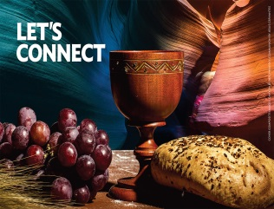
ONE GREAT HOUR OF SHARING OFFERING (PCUSA)
During the season of Lent, we celebrate that God connects with us through Jesus’ resurrection and connects us with "those who have least" — that’s how Matthew 25 puts it — and that’s what One Great Hour of Sharing is all about. Connecting.
Our gifts provide relief from natural disasters, food for the hungry, and support for the poor and oppressed.
This Lenten season, please give generously to
One Great Hour of Sharing...March 2 - April 17, 2022.
There will be offering envelopes and fliers with more information in the bulletins this week.

You can make a gift to Central Presbyterian Church and mark it for OGHS or you can go on the PCUSA website and make a donation:
https://specialofferings.pcusa.org/offering/oghs/

Family Promise Giving Day 2022
April 28, 2022
Family Promise Giving Day is a 24-hour online campaign to raise awareness and support for families battling homelessness. We're asking friends to "Give an Hour," whether that's an hour of time volunteering, an hour's worth of salary as a donation, or an hour spent raising awareness about the crisis of family homelessness. Visit our website (below) for more information!
https://giving-days.herokuapp.com/?dog_name=familypromise2022

Online Worship and Live Streaming Options
We are seeking to offer many ways for the church family, those who are friends of the church, and those who might be interested in being a part of a faith community to connect and be a part of worship. To start making this happen, we have added the option for Live-Streaming of the 9:00 a.m. Contemporary Worship service.

On Sunday mornings at 9:00 a.m., you can join us on the Central Presbyterian Church Facebook page. We will continue the pre-recorded option of worship with limited liturgy, and this will be uploaded to the church website CentralPresBristol.org and to Ann Aichinger’s Facebook page.

If you do join us online, we ask that you please make a “Comment” and let us know you are joining us! This will help us keep an accurate record of our attendance each Sunday. If you have any questions, please feel free to contact Josie Russell, our Social Media Coordinator.

Calendar for April 6 - 20, 2022

Wednesday, April 6 5:30 p.m. Lenten Dinner and Programs
7:00 p.m. Sanctuary Choir Practice
Thursday, April 7 9:00 a.m. Backpacks
10:30 a.m. Meals on Wheels
4:00 p.m. Care and Concern Committee Meeting
Sunday, April 10 Palm/Passion Sunday
9:00 a.m. Worship - Central Hall
10:00 a.m. Adult Sunday School
11:00 a.m. Worship and Communion -Sanctuary
ONLINE Worship
3:00-4:30 p.m. Middle School Youth - In-person
4:30-6:30 p.m. High School Youth - In-person
Monday, April 11 APPLE - SPRING BREAK
6:00 P.M. Embroiderer’s Club Board Meeting
7:00 p.m. King Institute for Faith and Culture
Lecture - Jeff Munroe in Central Hall
(TITLE: Frederick Buechner and the
Art of Listening to your Life)
Tuesday, April 12 11:00 a.m. Presbyterian Women - Hybrid Meeting
7:00 p.m. Sanctuary Choir Practice
Wednesday, April 13 7:00 p.m. Sanctuary Choir Practice
Thursday, April 14 7:00 p.m. Maundy Thursday Service - Central Hall
Friday, April 15 12:00 Noon Good Friday Service - Sanctuary
Sunday, April 17 (Easter Sunday) 9:00 a.m. Worship—Central Hall
11:00 a.m. Worship -Sanctuary
ONLINE Worship
(Easter Egg hunts during Children’s Church)
Monday, April 18 OFFICE CLOSED
Tuesday, April 19 12:00 Noon Staff Meeting
7:00 p.m. Session Meets
Wednesday, April 20 12:00 Noon Central Life
5:30 p.m. Dinner and Program in Central Hall
7:00 p.m. Sanctuary Choir Practice

Editorial Note:
This edition of the Central Life Newsletter had to be put together without Lynn Gilbert’s expertise due to her mother’s illness and need for care. So please excuse any errors, typos or disorganization of this newsletter. But we wanted to get the information out to you so you can be informed of what is happening in our church family.

Central Life
Central Presbyterian Church
331 Euclid Ave
Bristol, VA 24201-4013
Phone: 276-669-3157
Fax: 276-669-7362
Email: office.cpc@bvu.net
www.CentralPresBristol.org
Central Presbyterian Church
April 6, 2022

How to Keep in Touch:
www.facebook.com/CPCBristol: You do not have to sign-in or log on. Just click “not now” and the site will pop up. Scroll down to find the latest message.
www.CentralPresBristol.org: Click on “View Sermons” then scroll down to see Pastor Ann’s videos for each day.

Options for giving to the work and ministry of Central Presbyterian:
* You can give in a check, or cash, in the offering plate, dropped by the office, or mailed to:
Central Presbyterian Church
331 Euclid Avenue
Bristol, VA 24201-4013
* You can give through your online banking to Central.
* You can set up an automatic deposit from your account; please talk with the Finance Director on how to do this.
* You can TEXT to CentralPres (no spaces and Capital C and P) to 73256. You will be directed to make your donation through Realm.
* You can give one time, or regularly, through your Realm Connect profile.

How to contact us:
Ann Aichinger, Pastor ann.cpc@bvu.net
Robert Campbelle, Music Director robertcampbelle@gmail.com
Joy Smith-Briggs, Organist gvbjoyb@btes.tv
Josie Russell, Youth & Young Adult Dir. josieannrussell@gmail.com
Social Media Coordinator
Lynn Gilbert, Admin. Asst. office.cpc@bvu.net
Newsletter Editor
Mary Moffatt, Finance Director finance.cpc@bvu.net
Sumer Lowry, Kitchen Coordinator sumerlowry83@gmail.com
Michelle Blankenship Dir. of APPLE Academy applepreschool@yahoo.com
OFFICE HOURS: 9:00 a.m. to 2:30 p.m. Monday - Friday.

