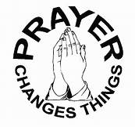
How Can I Make My Prayers More Meaningful?
__________________________________________
__________________________________________
__________________________________________

1 Thessalonians 5:17 KJV

Pray without ceasing.

What is an experience that I have had where I knew my prayers were heard and answered?
______________________________________________________________________________________________________________________________________________________________________________________________________________________________________

