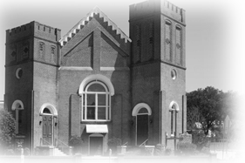

Sunday
Bulletin
Ladson Presbyterian Church
U.S.A.

11:00 a.m. |  |  | February 26, 2017
Rev. Jeryl Salmond, Minister
Transfiguration Sunday
Black History Sunday
GATHERING
Prelude
*Call to Worship: |  |  | Rev. Jeryl Salmond
Minister: | Let the radiance of Christ be evident among us:
People: | in our songs and our words; in our deepest thoughts and desires.
Minister: | Come, let us worship God!
*Morning Prayer: |  |  | Lachaska Salmond
***
*Opening Hymn:
AAHH #540 “”Lift Every Voice and Sing” (versus 1 and 3)
*Affirmation of Faith: | The Apostles’ Creed
Unison: I believe in God the Father Almighty, Maker of heaven and earth. I believe in Jesus Christ, God’s only Son, our Lord; who was conceived by the Holy Spirit, born of the Virgin Mary, suffered under Pontius Pilate, was crucified, died, and was buried; he descended to the dead. On the third day he rose again; he ascended into heaven, he is seated at the right hand of the Father, and he will come to judge the living and the dead.
I believe in the Holy Spirit; the holy catholic Church; the communion of saints; the forgiveness of sins; the resurrection of the body; and the life everlasting. Amen.
*The Lord’s Prayer
*Doxology:
BPH #592 “Praise God, from Whom All Blessings Flow”

Prayer of Confession:
Minister: | Let us confess our sins as we pray, saying:
(Unison) Though we want to walk with Moses and see God’s holy radiance, forgive us Father as we hide in the mist of our own desires, unable to perceive the presence of Your grace. While we want a world of justice and peace, forgive us Father as we walk in clouds of selfishness, unable to share Your loving-kindness. Though we want to follow Jesus up the mountain, forgive us father as we cower in fear, unable to bear the light of God.
Assurance of Pardon: |  | Minister
In the blazing light of God’s grace, Jesus touches us to say, “Get up and do not be afraid.” In the name of Christ, all is forgiven.
People: | Thanks be to God. Amen.
Welcome, Introduction and Announcements
Black History Presentation Christian Education
***
Hymn of Preparation:
AAHH #412 “We’ve Come This Far by Faith”
THE WORD
Prayer for Illumination: Jadyn Salmond
Reveal your presence to us this day, O God of light, love, and glory. As you did to your servants at the foot of the mountain, send your Spirit to show us your story. May the brilliance of your face illuminate this place as we dare to proclaim your Word and may we, your people, always be able to tell what we have heard. Amen.
Scripture Lesson: Matthew 17:1-9
Choral Response:
RH 550 “Write These Words in our hearts, we beseech thee O Lord.”
***
Special Selection
Sermon: We Can’t Sit This One Out
RESPONSE OF THE PEOPLE
*Invitational Hymn:
AAHH #563 “I Want Jesus to Walk with Me”
Giving of our Tithes and Benevolent Offering
*Offertory Prayer and Response
BPH#428 “We Give Thee but Thine Own” (verses 1 & 5)
GOING FORTH TO SERVE GOD
*Closing Hymn:
AAHH#391 “I Will Trust in the Lord”
*Charge and Benediction
*Congregational Response: “Threefold Amen”
Closing Selection
Postlude

The Worship Ends…The Service Begins

*Please Stand ***Ushers May Seat Worshippers
Announcements
Welcome Visitors: It is a joy to have you worship with us on this Lord’s Day. We pray that you will find God’s presence and love among us. Please come and worship with us again.
***************
Special Announcement
The door to the fellowship hall will remain locked during Sunday morning worship service. If you require access to the fellowship hall, please see one of our ushers.

General Announcements

- Feb. 26th: Homelessness Feeding Mission
- Wednesday, March 1, 2017: Beginning of Season of Lent
- March 5th: Men’s Day
- April 16th: Easter Sunday

Monthly Assistance Schedule
 | Morning Prayer | Scripture Reading
February | L. Salmond | L. Salmond/J. Salmond
March | C. Smith | D. Randolph
April | H. Pride | L. Pride

Ladson…Where The Word Is Heard
-Rev. Jeryl Salmond

To learn more about church, visit our website at
www.ladsonpres.org

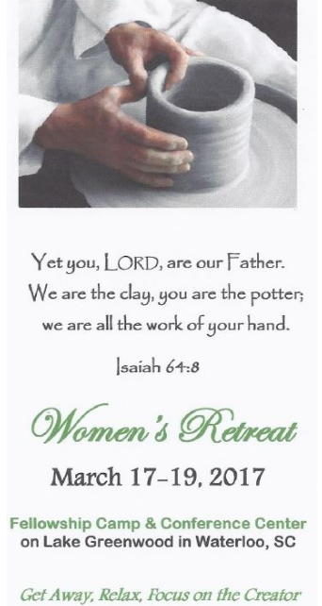
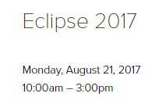
Summer Camp Registrations are ready to be viewed at https://www.campfellowship.org

https://www.campfellowship.org/womensretreat

Little Known Black History Fact
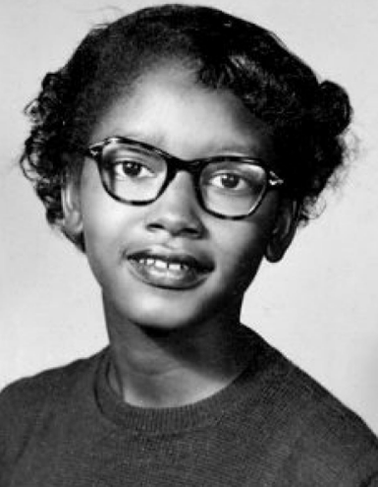 | Before there was Rosa Parks, there was Claudette Colvin.  Most people think of Rosa Parks as the first person to refuse to give up a seat on a bus in Montgomery, Alabama. There were actually several women who came before her; one of who was Claudette Colvin.
It was March 2, 1955, when the fifteen-year-old schoolgirl refused to move to the back of the bus, nine months before Rosa Parks’ stand that launched the Montgomery bus boycott. Claudette had been studying Black leaders like Harriet Tubman in her segregated school, and those conversations had led to discussions around the current day Jim Crow laws they were all experiencing. When the bus driver ordered Claudette to get up, she refused. “It felt like Sojourner Truth was on one side pushing me down, and Harriet Tubman was on the other side of me pushing me down. I couldn't get up."
Claudette Colvin’s stand didn’t stop there. Arrested and thrown in jail, she was one of four women who challenged the segregation law in court. If Browder v. Gayle became the court case that successfully overturned bus segregation laws in both Montgomery and Alabama, why has Claudette’s story been largely forgotten? At the time, the NAACP and other Black organizations felt Rosa Parks made a better icon for the movement than a teenager.

Scripture: Matthew 17:1-9
Sermon Title: We Can’t Sit This One Out

Main Points

Matthew 17:1-9
17 After six days Jesus took with him Peter, James and John the brother of James, and led them up a high mountain by themselves. ² There he was transfigured before them. His face shone like the sun, and his clothes became as white as the light. ³ Just then there appeared before them Moses and Elijah, talking with Jesus. ⁴ Peter said to Jesus, “Lord, it is good for us to be here. If you wish, I will put up three shelters—one for you, one for Moses and one for Elijah.” ⁵ While he was still speaking, a bright cloud covered them, and a voice from the cloud said, “This is my Son, whom I love; with him I am well pleased. Listen to him!” ⁶ When the disciples heard this, they fell facedown to the ground, terrified.⁷ But Jesus came and touched them. “Get up,” he said. “Don’t be afraid.”⁸ When they looked up, they saw no one except Jesus. ⁹ As they were coming down the mountain, Jesus instructed them, “Don’t tell anyone what you have seen, until the Son of Man has been raised from the dead.”

