Edgewood Baptist Church
1807 Infinity Road · Durham, North Carolina 27712-8710
Church Office: (919) 471-2664 Web: http://www.edgewoodbaptistdurham.com

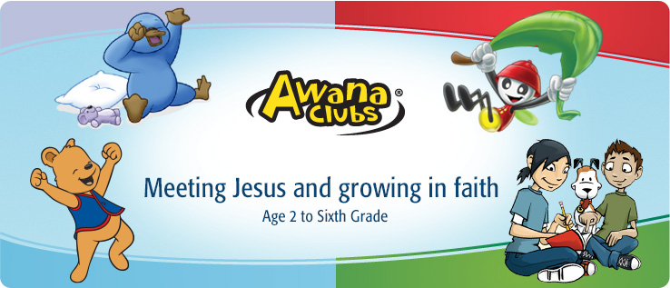
Come join us on Sunday afternoons
Beginning September 18th, 2016
4:00 p.m. - 6:00 p.m.
Children - Age 2-6th grade

Pre-registration forms
Please print the registration forms below:

We are sorry you cannot complete these forms on line but due to confidential information requested we would prefer you either mail or scan and email to the attention of Jackie Williams

Edgewood Baptist Church
1807 Infinity Road
Durham NC 27712
Email – gpwjfw@msn.com

Page 1
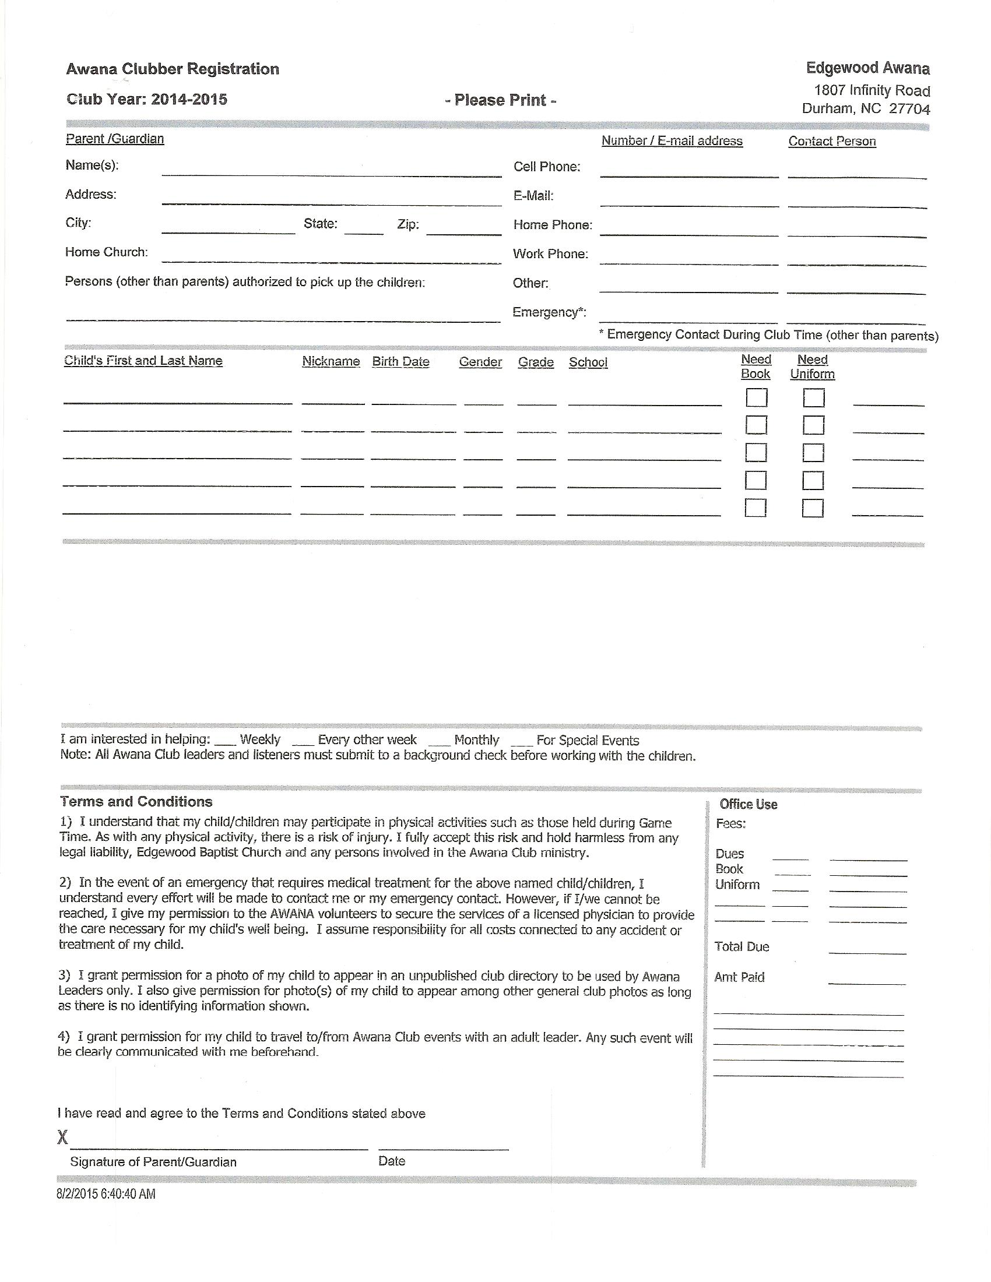

Page 2
Edgewood Baptist Church
1807 Infinity Road · Durham, North Carolina 27712-8710
Church Office: (919) 471-2664 Web: http://www.edgewoodbaptistdurham.com
Release Form - 2015
I hereby grant permission for
_____________________________________________________________________________________ (child/children's name)
to participate in the Edgewood Baptist Church activities for CALENDAR YEAR 2015-2016, and to engage in all activities of the Awana Group. This includes permission to ride in the church van and/or designated chaperones vehicle on any trip sponsored by Edgewood Baptist Church.
I hereby also grant permission and authorization to the sponsors of the group to seek and obtain such emergency care, first aid, or medical treatment at my expense as may be necessary in the event my child/children should be injured or becomes ill for any reason.
I hereby authorize the doctor, dentist or such medical agency chosen or retained by the leader or sponsors to render the necessary emergency care, first aid, and/or medical treatment or service for the health and welfare of my child/children.
The leader, sponsors, other persons and Edgewood Baptist Church engaged in helping my child/children's are hereby expressly relieved of any and all liability for damage which may result from injury incurred while participating in these activities or their good faith efforts to render such necessary emergency care and assistance as it may be needed.
IN CASE OF EMERGENCY NOTIFY:
____________________________________________________(NAME AND RELATION TO CHILD)
____________________________________________________(TELEPHONE NUMBER)
____________________________________________________(PARENT'S SIGNAURE)
____________________________________________________(CHILD'S SIGNATURE)
INSURANCE INFORMATION - POLICY NAME ___________________________________________
POLICY NUMBER ____________________________________________________________________
MEDICAL INFORMATION - Does either of your child/children have any medical conditions or allergies that might need attention: _______________________________________________________
_____________________________________________________________________________________
Is the child/children allergic to any medication? ______________________________________________
Is the child/children currently taking any medication?__________________________________________
Approximate date of last TETANUS shot? __________________________________________________
Other medical information _______________________________________________________

Page 3
Edgewood Baptist Church
1807 Infinity Road · Durham, North Carolina 27712-8710
Church Office: (919) 471-2664 Web: http://www.edgewoodbaptistdurham.com

AWANA CLUB

2015-2016

Product Price List

Puggles Shirts $10.00
Clubbers Shirt $15.00
Clubbers Vest $15.00
Handbook $9.00
Dues $ .50 per week

Attention Parents,
Please help your child/children to keep up with their books. We have had problems with the children losing their handbooks several times. Please stress to them that they need to keep up with their book and bring them each week.
Payment plans may be setup if you are unable to pay it all at one time. Also check with us, sometimes we have a used one that the children have turned back in or outgrown theirs.
Thanks

Larry Jacobs,
Commander/ Awana

Page 4

