Welcome to Worship

CAMPBELLTOWN UNITED CHRISTIAN

God’s People Gather to Worship (response)
The Lord be with you: and also with you.
Prayer of Confession
Call to Worship (response)
The Lord is our light and our salvation; whom shall we fear?
The Lord is the stronghold of our lives; of whom shall we be afraid?
The Lord will protect us and guide us.
Let us gladly offer ourselves before our God with shouts of joy; let us sing praises to the Lord, our God.

Hymn* # 178 “How Firm A Foundation” Unknown
Prayer of Invocation
Hymn # 17 “Joyful, Joyful, We Adore Thee” VanDyke
First Reading Isaiah 43 : 1-7
Gospel Luke 3 : 15-17
Prayer for Illumination*
Anthem* “Gloria Patri”
The Daily Office: Readings For The Week
From the Book of Common Prayer, Daily Office, Year One
Day | Psalm | Old Testament | New Testament | Gospel
Sun | 46,97 | Isaiah 52:7-10 | Rev. 21:22-27 | Matt. 12:14-21
Mon | 103 | Isaiah 52:3-6 | Rev. 2:1-7 | John 2:1-11
Tue | 117,118 | Isaiah 59:15-21 | Rev. 2:8-17 | John 4:46-54
Wed | 121,122,123 | Isaiah 63:1-5 | Rev. 2:18-29 | John 5:1-5
Thu | 138,139:1-17 | Isaiah 65:1-9 | Rev. 3:7-13 | John 6:1-14
Fri | 148,150 | Isaiah 65:13-16 | Rev. 3:14-22 | John 9:1-12,35-38
Sat  Need to contact us?  Pastor Tom and Deb Clawser  150 Oxford Road, Annville, PA 17003  PH: (717) 838-5056 FX: (717) 473-3197  Email: pastortom@fontanachapel.org | 98,99 | Isaiah 66:1-2,22-23 | Gal. 3:23-29
Message “God’s Unmerited Favor”
Granting Success to His People
Prayer of Consecration
Presentation of Tithes and Offerings
The Sacrament of Holy Communion
Prayer of Blessing* *please stand as you are able

The BIG Idea: God’s unmerited favor allows us to reach the heights He desires for us.
prayer wall
Baby Peyton
Bechtel family
Christine
Copenhaver, Alice
Dove Family
Eddinger, Donald
George, Dorothy
Hodge, Marilyn
Keller, David
Keyton, Pauline
Kivler, Catherine
Leibfried, Jeanne
May, Mike
Michele
Miller, Joyce
Montgomery, Janet
O’Neal, Betty
Root, Anju
Sears, Andrew
Sears Family
Via, Pauline
homebound
Hoffsmith, Evelyn
Smith, Eva
INTRODUCTION TO THE SCRIPTURES 6-JAN-2019
EPIPHANY SUNDAY (Year C)

ISAIAH 43:1-7. The passage is the concluding part of a longer poem beginning in 42:5. The unknown prophet of Israel’s Babylonian exile authored this poetic promise of the return of the exiles to their homeland. Like all prophets, he speaks for God, assuring those dwelling in foreign lands that, in spite of their great difficulties, they would be brought home. The basis for this beautifully expressed faith is God’s ancient covenant with Israel as God’s chosen people.

LUKE 3:15-17. Luke gives a much briefer account of Jesus’ baptism than the other gospels. It seems little more than an ending to his narrative about the ministry of John the Baptist. The essential details are the same, however. Luke records the actual baptism, the descent of the Spirit as a dove, and the divine blessing.

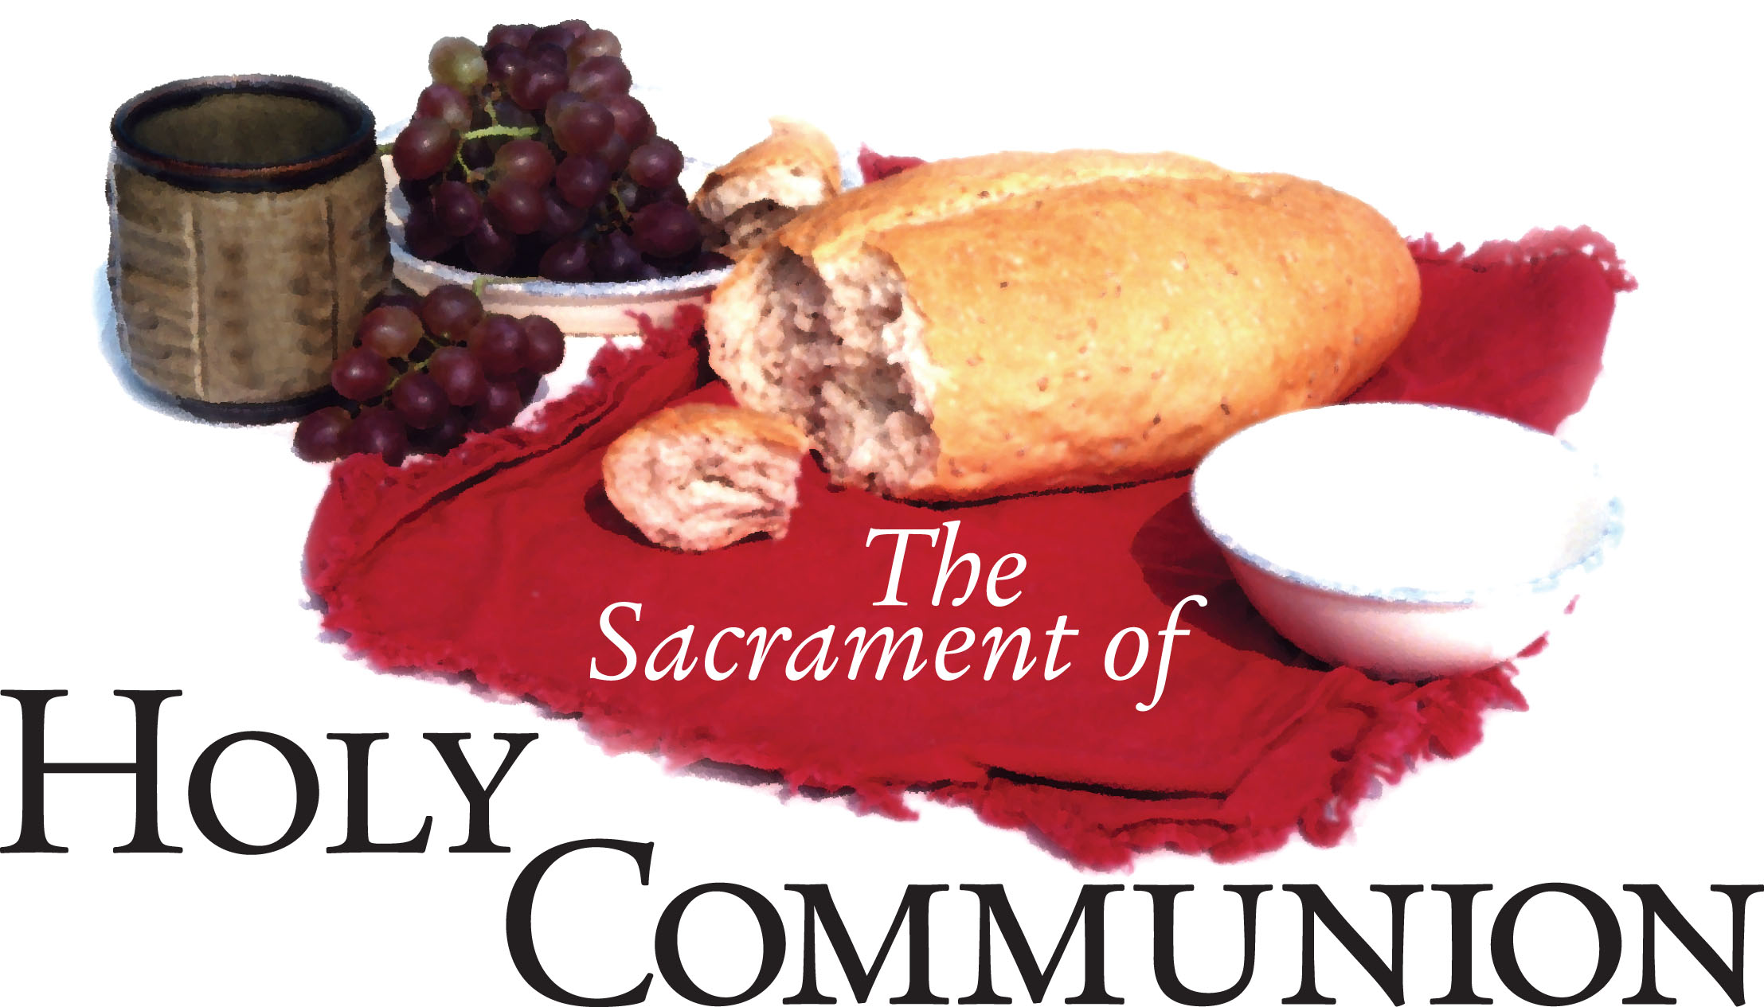
The Sacrament is open to all who have been saved by the blood of Jesus, and continue in Him. We rejoice as we share this blessed time together.

Mark Your Calendar
Today | Sacrament of Holy Communion
Jan 18 | 3rd Friday Potluck | 6:00p
Prayer & Praise/DayOne on hiatus until—Mar. 5

Notes

