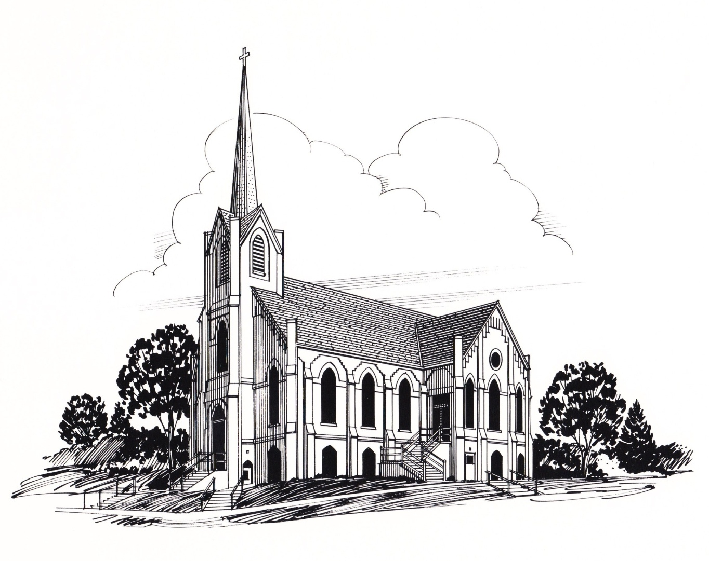

Inside This Issue
Pastor’s Column 1
Announcements, 2
Sunday School 3
Sermon Series 3
Prayers of Concern, Birthdays and Anniversaries 4
Church Council Minutes 5
The November Calendar 6
Ushers, Greeters, Acolytes 7
Video, Sound & Organists 7
Dorcas Society, 7
Altar Committee & Sewing Meetings & W.O.W. 7
Christian Humor to Tickle Your Life 8

The Christmas season is a special
The last day of October is Reformation Day, and on this day we can remember the gift of forgiveness and eternal life that God gives through faith in Jesus.
As we think of this faith, it can possibly remind us of people we have known who have been called from this life and whose faith touched our lives and helped us to believe.
The first day of November is All Saints Day, and it is a special day in which we remember these inspiring people of faith. We can also remember the heavenly home, or “better country” that has been prepared for them and for us, in Jesus.
As we trust in Jesus, and observe All Saints Day may it be special time to whisper a prayer of thanks to God for the people of faith he has put in our lives, and to thank him for his promise of eternal life.

God Bless,
Pastor Mark

November 2014 Special Days
- All Saints' Day — Nov. 1
- Daylight-Saving Time Ends — Nov. 2
- Veterans Day — Nov. 11
- Christ the King Sunday — Nov. 23
- Bible Sunday — Nov. 23
- National Bible Week — Nov. 23-Nov. 30
- Thanksgiving Day — Nov. 27
- First Sunday of Advent — Nov. 30

2014
By Rev. Mark Eldal

November 2014
Volume 1, Issue 10

First Ev. Lutheran Church,201 N. Davis, PO Box 152 ,Oakland, NE, 68045 Office - (402) 685-5764

www.firstlutheranchurch-oakland.com, firstlutheranchurch_152@q.com Fax - (402) 685-5183

THE SPIRE

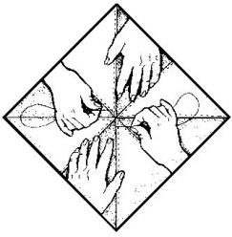
ANNOUNCEMENTS
The sewing ladies will be packing the quilts for Lutheran World Relief and Open Door Mission on Monday Morning November 3rd at 8:30 a.m. They would appreciate the help of some strong men to handle the heavy boxes of quilts. The ladies have made around 200 quilts this past year! WHAT AN AMAZING ACCOMPLISHMENT!!
On Sunday, November 2, the Burt County Brass Quintet will be leading our worship service.
WE WOULD LIKE TO THANK NANCY JOHNSON for being a delegate to the LCMC assembly in Des Moines, IA. We would also like to thank her for giving her report during the Sunday Morning Church Service.
Small Group Study Returns!! -- Work as Worship
Many Christians—from the CEO to the teacher to the stay-at-home mom—spend a great deal of time working and yet do not realize how their work intersects with their faith. They compartmentalize their faith to Sunday morning and see the rest of their week as having little to do with their walk with God. Scripture, however, makes no division between the sacred and secular parts of our lives. God gives us our work, talent and skills so that through them we might worship Him.
This six-part Bible study resource will challenge all of us to consider the reason God calls us to work. It will cause you to consider why He may have you in your current position and encourage you to look beyond how your job makes you feel and see purpose and significance in your work.
If you would like to explore this topic, our first meeting with be Wednesday, Oct 15th at 6:45 pm - 8:00 pm at church. With subsequent meetings held on the 1st & Third Wednesday of the month. Everyone is welcome! For questions, please contact Nancy Johnson 402-620-5324.
CHRISTMAS BUS TRIP - The church is planning a trip to the Holland Center in Omaha on Sunday, December 7th to see the Salem Baptist Church Choir. Come enjoy the harmonious sounds of Omaha's nationally recognized choir. This upbeat Christmas celebration will feature a combination of blended classics and new music intertwined with unforgettable drama and expertly choreographed dance.
The cost per ticket is $16.50 and the bus ride is $13.00 per person. Make checks payable to First Lutheran Church in the amount of $29.50. After the show we will have a meal at Farmer Brown’s restaurant which will cost $10 - $15. The bus will leave at around 2:00 from the church parking lot. If interested you may sign up with Candace Johnson at church or give her a call at home (402)685-5718. Come join us for an exciting day of fun and fellowship.

FIRST EV. LUTHERAN CHURCH IS PART OF LCMC, Lutheran Congregations in Mission for Christ.
To find information regarding our synod – http://www.lcmc.net/.
To Email our church - firstlutheranchurch_152@q.com
Please check out our updated website: www.firstlutheran-oakland.com
and we are now on Facebook as well.. come see our page…
https://www.facebook.com/pages/First-Lutheran-Church-Oakland-NE/308938792621977
THE SUNDAY SCHOOL CLASSES WENT TO THE HARVEST MOON PUMPKIN PATCH on Sunday 10/19 for our fall outing! They met at the pumpkin patch at 10:30 following church services. Lunch and admission were provided. There was a phenomenal turnout and a great time was had by ALL.

Please join me in thanking all the Sunday school teachers that dedicate their time:
- Preschool =Jodi Peterson & Angie Rennerfeldt
- Kindergarten & First Grade =Keri Thomsen
- Second & Third Grade =Susan Mulder
- Fourth Grade =Jen Anderson
- Fifth & Sixth Grade = Andy Rennerfeldt & Bev Peterson
- Seventh & Eighth = Janelle Seagren
- Cindy Blanc & Jill Johnson for their musical talents

SERMON SERIES
God Tweets - Messages from God sent to where we live.
We will look at passages from scripture that can have special meaning for our lives.
- Week 1 – Whosoever will …

- Week 2 – I will give you back…

- Week 3 – You will hear a voice behind you…

- Week 4 – I would rather be a doorkeeper…

- Week 5 – I looked for a man…

- Week 6 – They overcame him…

- Week 7 – However, The fool says…

FIFTY-ONE DAY SPIRITUAL ADVENTURE
On September 28th we began the adventure of reading through the Psalms in fifty one days. There are one hundred fifty psalms so this will mean reading about three a day.
As you read the psalms ask yourself the following questions:
- What was the psalmist feeling as he wrote the Psalm?
- Have I ever felt the same emotions as the psalmist?
- Can I express my emotions to God and ask him to minster in my life?
- Does God invite me to pour my heart out to him?
- Can l live in such a close personal relationship to God that I can talk to him about everything in my life?

IN OUR PRAYERS OF CONCERN PLEASE INCLUDE: Jan Nelson(Gordon Nelson’s sister), Kyle Brand, Bill Dix, Judy Hall, Sandra Johnson, Rosemary Anderson, Bob Wonka, Fauniel Paulson, Allen Schrock, Charlie Ray, Gina (Tanksley) Culbertson, Robert Johnson, Joel Paulson, Tim Dame, Dick Miller, Connie Peterson, Rich Tomasek, Oliver Nimmo, Delwin Benne, Joseph Vandry, Landon Johnson, Gene Hansen, Gail Elsasser, Grace Meints, Thad Nelson serving in Kuwait and all of our servicemen and women, our shut-ins and our youth ministry.

We praise God that Taylor Peterson, grandson of Dr. and Bev Peterson is home safely from Oman.

NOVEMBER ANNIVERSARIES
1 – Reg & Pam Linder
7 – Perry & Teresa Rogers
8 – Kyle and Laura Schnoor
10 – Mark & Laurie Carlson;
Gail and Gary Elsasser
11 – Darrell & Cheryl Denker
14 – Norman & Janice Case
25 – Dan & AnnaBelle Olson
27 – Harold and Donna Baldwin
29 – Chad & Andrea Schiermeyer

NOVEMBER BIRTHDAYS
1 – Timothy Magnusson
2 – Rosemary Anderson, Dale Jones
3 – James Peterson, Verlee Wickstrom, Tom Meyer
4 – Dick Miller, Ashten Rennerfeldt
5 – David Pearson
6 – Jordan Johnson
7 – Ryan Nelson, Clohee Stucky
9 – Julie Easton, Meghan Ahrens
10 – Preston Peterson Keesling,
11 – Charles Krutilek
13 – Paula Modlin
14 – Keith Anderson, Megan Corwine,
Tammy Schnick, Sam Schmidt
16 – Janice Case
18 – Larry Anderson, Ellen Magnusson
19 – Greg Ray
20 – Megan Bousquet
22 – Donna Larson, Robert Case
23 – Carla Corwine, Roger Ray, Makenna Miller
26 – May Taylor
28 – Norm Case, Blake Denton, Ila Engdahl,
Tammy VonEssen, Janet Wiltse
29 – Debbie Krutilek, Sandra Mallette, Ashlie Slatt
30 – Fauniel Paulson

First Evangelical Lutheran Church
Oakland, Nebraska
The church council met October 13, 2014 at 7:30 p.m. In attendance were Roger Moderow, Sandy Husar, James Schrock, Carl Magnusson, Jan Wiltse, Kylie Penke, Greg Ray, Jim Pelan, Jon Seagren and Mona Tanksley. Also in attendance were Pastor Eldal and Hannah Hyslop.
After opening the meeting with devotions, Roger called the meeting to order. Pastor presented his report for August and September. He noted that confirmation is going well and that Jean Swanson is helping with this.
The minutes of the previous meeting were read and a motion was made by Kylie to accept them. Motion seconded by James and carried.
Hannah reported on her activities and ideas as the media ministry intern. She discussed plans for using Instagram and Facebook as well as the church’s website as ways to provide information and inspiration via the internet.
Evangelism and Financial: The Evangelism committee has discussed recognizing various milestones for kids throughout their church life, i.e. Bibles given to the third graders, confirmation, etc. Jon reported on what he has gathered for information regarding insurance for the building and replacement cost. He will clarify and get in writing some questions raised regarding what is included as part of the building. We discussed dropping the extra insurance we currently have on the audio/visual equipment. The August and September profit and loss statements were reviewed and discussed. A motion was made by Carl to accept the financial report. Motion seconded by Jim and carried. The health insurance for Pastor was discussed and a motion was made by Sandy, seconded by Greg to have Pastor’s health insurance benefits remain as they were last year. Motion carried. We discussed the organ and parking lot projects noting they are both completed and that thank you notes were sent to contributors. A dedication was discussed with more plans yet to be determined.
Music and Worship: It was noted that choir is going well with the new director. Sandy reported on the Worship Committee activities.
Property Committee: It was reported that a sign has been installed in the parking lot. Jim has repaired the bell as well as sprayed the building for bugs. The hand rail on the east stairs is loose.
Old Business: Use of communion cards was discussed and we will check on prices, but will get some ordered. Kylie offered to look into what the problems are with the current computer program that logs church records. Other programs will be explored also.
New Business: Pastor reported on the LCMC convention he and Nancy Johnson attended recently. The WOW kick off was held in September with all groups viewing a movie. A WOW women’s retreat will be October 18. The Pub has been going well after football games. It was noted that the church has some excess items that we need to get rid of. Cheryl has contacted the Orphan Grain Train as well as talked to someone in Pilger that could possibly use some of these items. There was discussion on possibly replacing the tables in the multipurpose room, though no decision was made. A new CD recorder has been installed. A new DVD duplicator has been in place since the spring and we will check with Tess to make sure the DVDs are picked up and delivered to the nursing home.
Communion helpers for Saturday, November 1 – Arla Ogden

October Finances

Commitments $13,897.00
Building Use
Designated
Parking Lot $2,555.00
Organ Repair $ 550.00
Sunday School $ 31.98
Memorial $ 35.00
Misc $ 597.85
Total $17,666.83
Sunday, November 2 – Sandy Husar
Devotions for November 3rd meeting – Kylie Penke
The meeting adjourned with all praying The Lord’s Prayer.
October Attendance
4&5 ............183
11&12........... 173
18&19 ...........224
25&26........... 191

Mona Tanksley, Secretary

November 2014
Sun | Mon | Tue | Wed | Thu | Fri | Sat
 |  |  |  |  |  | 1
 |  |  |  |  |  | 5:30PM COMMUNION SERVICE
2 | 3 | 4 | 5 | 6 | 7 | 8
9:30AM COMMUNION SERVICE  10:30AM FELLOWSHIP & SUNDAY SCHOOL  11:00AM BIBLE STUDY  CHOIR SINGS | 8:30AM SEWING GROUP | 8:30AM SEWING GROUP | 9:30AM BINGO @ OAKLAND HEIGHTS  6 - 8P.M. 7TH GRADE CONFIRMATION  8:00PM CHOIR PRACTICE | 8:00PM N.A. MEETINGS |  | 5:30PM WORSHIP SERVICE
9 | 10 | 11 | 12 | 13 | 14 | 15
9:30AM WORSHIP SERVICE  10:30AM FELLOWSHIP AND SUNDAY SCHOOL  11:00AM BIBLE STUDY  SUNDAY SCHOOL SINGS | 8:30AM SEWING GROUP  4PM WOW EXECUTIVE MEETING | 8:30AM SEWING GROUP  VETERAN’S DAY | 9AM 2 PM, 6PM WOW GROUP MEETINGS  6 - 8PM 8TH GRADE CONFIRMATION  9AM, 2 PM, 6PM WOW MEETINGS  8:00 PM CHOIR PRACTICE | 8:00PM N.A. MEETINGS |  | 5:30PM WORSHIP SERVICE
16 | 17 | 18 | 19 | 20 | 21 | 22
9:30AM CONTEMPORARY SERVICE  10:30AM FELLOWSHIP AND SUNDAY SCHOOL  11:00 AM BIBLE STUDY  6:00 PM KOINONIA MEETING | 8:30AM SEWING GROUP | 8:30AM SEWING GROUP | 6 - 8 P.M. 7TH GRADE CONFIRMATION  8:00 PM CHOIR PRACTICE | 8:00PM N.A. MEETINGS |  | 5:30PM WORSHIP SERVICE
23 | 24 | 25 | 26 | 27 | 28 | 29
9:30AM WORSHIP SERVICE  10:30AM FELLOWSHIP AND SUNDAY SCHOOL  11:00 AM BIBLE STUDY | 8:30AM SEWING GROUP | 8:30AM SEWING GROUP | 6 :00 pm CONFIRMATION  DINNER  7:30PM THANKSGIVING EVE SERVICE  CHOIR SINGS | 8:00PM N.A. MEETINGS  THANKSGIVING DAY
30
9:30AM WORSHIP SERVICE
10:30AM FELLOWSHIP AND SUNDAY SCHOOL
11:00 AM BIBLE STUDY
CHOIR SINGS

Nov 2014 Ushers
Nov 2nd - Roger Moderow, Job Egbers, Johnnie Johnson & Terry Johnson
Nov 9th - Jim Nelson, Norm Case, Chad Linder and Jerry Benne
Nov 16th - Harley Nelson, Norm Case, Sam Schmidt and Kent Johnson
Nov 23rd - Norm Case, Clare Wilste, Gary Case and Jack Carstenson
Nov 26th - Thanksgiving Eve - Job Egbers and Zach Lierman
Nov 30th - James Jorgenson and Austin Jorgenson

November 2014 Greeters
Nov 2nd - Melinda Johnson and Julie Johnson
Nov 9th - Elisabeth Linder and Linda Carlson
Nov 16th - Ashley Carr and Joan Johnson
Nov 23rd - Tammy Case and Judy Dix
Nov 30th - LeAnn Jorgenson and Lindsay Jorgenson

Nov 2-Katie Miller Nov 2-Garrison Dodge
9-Jacob Deemer 9-Katie Miller
16-Jared Krutilek 16-Jacob Deemer
23-Megan Bousquet 23-Jared Krutilek
30 -Lane Peterson 30-Megan Bousquet
Dec 7-Ian Lundquist Dec 7-Lane Peterson

Nov 3 – Dan Tanksley
9 – Tess Johnson
16 – Jim/Dan
23 – Jim Pelan
26 – Tess Johnson
30 – Tess Johnson
Dec 1 – Dan Tanksley

Nov 2–Bryan Bohn
9– Billye Pearson
16–Ruth Wallerstedt
23 –
26 – Bryan Bohn
30 - Bryan Bohn

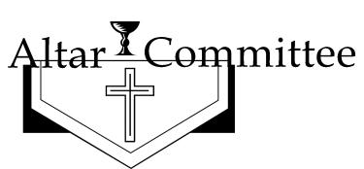

Shirley Olson and Sandy Mallette

SEWING GROUP MEETS every Monday & Tuesday morning
at 8:30 a.m. - 12:00 p.m.
November 5………... Bingo @ O.H. 9:30 a.m…...Hannah
November 9 ………. Devotions @ O.H. 2:30 p.m. …….Mary
November 10 ……… Executive Meeting ….4:00 p.m.
November 12 ……….Group Meetings 9 AM, 2 PM, 6 PM
Clean Kitchen ……….Ruth

Dorcas Society - November 26 @ 2:00 p.m. @ Oakland Heights
Paula Stevenson, Marcee Tomasek, Tess Johnson Sunday, November 02, 2014
Tamera VonEssen, Linda VonEssen, Jan Wiltse, Sunday, November 09, 2014
Sarah Wallace, Verlee Wickstrom, Cheryl Denker Sunday, November 16, 2014
Nancy Wonka , Julia Wuestewald, Patty Miller Sunday, November 23, 2014
Mary Paulson, Ruth Blomenkamp, Jan Wiltse Sunday, November 30, 2014
Cynthia Blanc, Jo Ann Brudigam, Tess Johnson Sunday, December 07, 2014

Thank you for your help in these important areas. If you can't be here, please find someone to take your place.

CHRISTIAN HUMOR TO TICKLE YOUR LIFE

2014

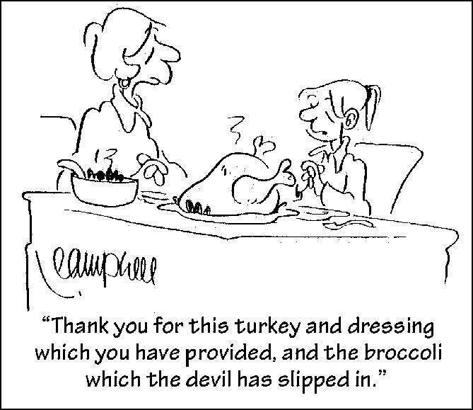
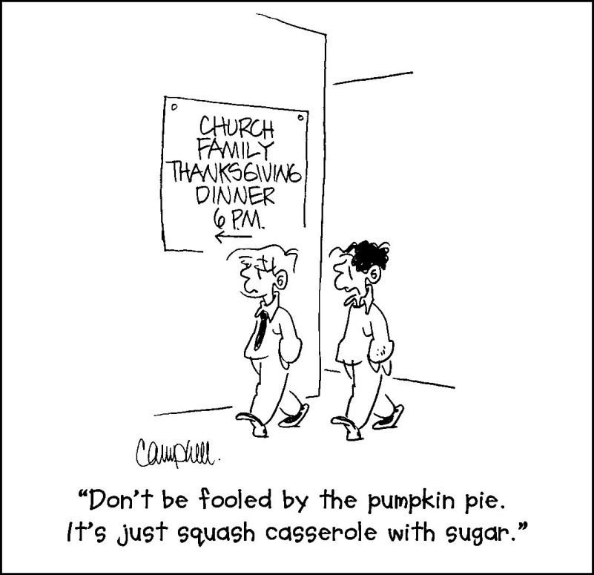
We’re on the Web!
Visit us at:
www.firstlutheran-oakland.com
We are committed to providing spiritual enrichment to ALL who seek the Lord.

First Ev. Lutheran Church
PO Box 152, 201 N. Davis
Oakland, NE 68045

Phone:
402-685-5764

Fax:
402-685-5183

E-Mail:
firstlutheranchurch_152@q.com

