A Day at Fellowship of the Rockies Preschool

8:30 a.m. Arrival Time. Staff greets class in the Welcome Center and we go downstairs as a group. We put away our coats.

8:40 a.m. Opening Circle Time. We introduce the day’s activities, special projects, calendar and weather.

9:00 a.m. Centers. Centers are open for children to choose activities.

10:00 a.m. Circle Time. Bible story is introduced or a story is read.

10:15 a.m. Snack time. Clean up
and wash up with a bathroom break and playground time.

11:15 a.m. Small group activities.

11:45 a.m. Circle Time.

11:50 a.m. Clean up, collect our things, put on our coats. We go upstairs.

12:00 p.m. Good-bye! Our school day ends.

Arcturus
W. Cheyenne Blvd.
Rt. 24
Cresta Dr
S. 8th St.

North
115
I-25

A Ministry of
Fellowship of the Rockies
1625 S. 8th Street Colorado Springs, CO 80905
email: preschool@forchurch.org

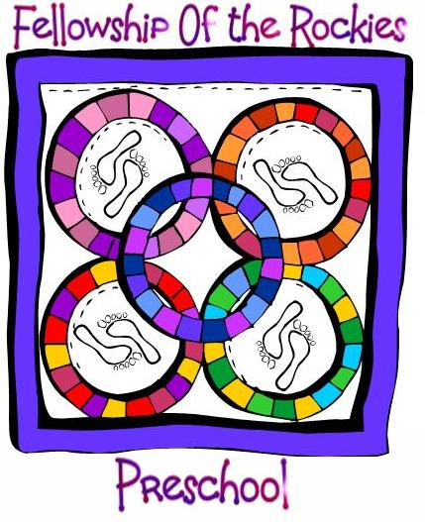

2020-21

A Christian early education program
for children ages 3 - 5

8:30 a.m. to 12:00 p.m.
August 25 - May 26

3 days per week

Church Office
633-4659
www.forchurch.org

Christian Mission Statement
To provide a meaningful early childhood education experience where each child is nurtured to learn, develop and grow as a child of God.
Educational Philosophy
Fellowship of the Rockies believes each child is a unique gift from God and should be respected and taught as an individual. Age appropriate learning experiences allow children to progress at their own pace and experience success as they develop mentally, physically, spiritually, socially and emotionally.
We believe in:
- Supporting a growing relationship with Jesus Christ by teaching about and modeling Jesus’ love in an age-appropriate environment.
- Building loving, nurturing relationships between Christian educators, children and their families
- Providing curriculum and policies that reflect the diversity of children and families in our community and the world around us.

Our Staff
Our staff is made up of dedicated individuals with a love for children. Our director, Mrs. Lori Taloumis, has 30 years of experience teaching, a bachelor’s degree in Elementary Education and a master’s degree in Early Childhood /Special Education. She has her certification as a childcare director through the state of Colorado. Our staff members are fully qualified as teachers and assistants. All staff participate in early childhood training, staff development, as well as CPR and first-aid training.

Tuition Rates
4 year olds attend 3 days a week T, W, TH ($220/month). 3 year olds may attend 3 days a week T, W, TH ($220/month) or 2 days a week, T, TH ($190/month). A discount of $20 per month is given to families with 2 siblings enrolled in the preschool. Both 3’s and 4’s may stay on Tuesday until 1:00 p.m. to eat their bag lunch for an additional charge of $10 per month.
Our Classes
Our class size is limited to 14 children. There is one teacher and one teaching assistant in each classroom. The children will play in activity centers, develop cooperation, listening and creativity skills, move and sing to music and learn beginning reading and math skills. A Bible story will be introduced with each unit of study.

Registration

To enter the program you must have a copy of your child’s birth certificate and a completed registration form. Prior to starting school, your child must have an immunization record signed by a physicians’ office and a current health appraisal form with a physical signed by a health professional and turned in to the preschool.

A nonrefundable Registration Fee of $75 is due at the time of registration. Registration forms may be picked up at the church office, by calling 633-4659 or on our web site www.forchurch.org.

Students

The 3 year olds must be 3 by 10/1/20.
Children with Sept. 1 – Oct. 1 birthdays may enroll, but must begin school after their birthday due to the state licensing “age 3” requirement.

All children entering the preschool must be toilet trained. We ask that parents provide morning snacks for a week at a time on a rotating basis. We are a peanut-free preschool due to allergy concerns. We need to be informed of any food allergies before the start of preschool.

