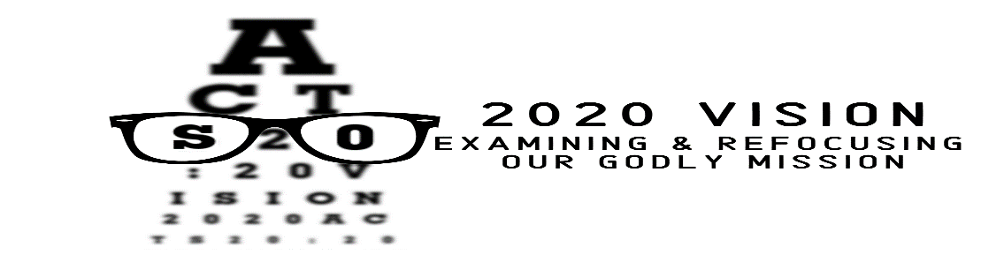

Pastor Tim Fillmore – Parkway Hills Church – January 26, 2020

Acts 20:20
“²⁰You know that I have not hesitated to preach anything that would be helpful to you but have taught you publicly and from house to house.”

THE CHURCH EXISTS…
TO SEEK AND OFFER FORGIVENESS!

1 John 1:9
“⁹If we confess our sins, he is faithful and just and will forgive us our sins and purify us from all unrighteousness.”

REASONS PEOPLE DON’T FORGIVE
BLAME
STUBBORNNESS
FAILURE TO FORGIVE

2 Corinthians 5:17
“¹⁷Therefore, if anyone is in Christ, he is a new creation; the old has gone, the new has come!”

1 John 1:9-10
“⁹If we confess our sins, he is faithful and just and will forgive us our sins and purify us from all unrighteousness. ¹⁰If we claim we have not sinned, we make him out to be a liar and his word has no place in our lives.”

REASONS PEOPLE SHOULD FORGIVE
__________________

Acts 3:19
“¹⁹Repent, then, and turn to God, so that your sins may be wiped out, that times of refreshing may come from the Lord.”

REASONS PEOPLE SHOULD FORGIVE
IT’S __________________

James 5:126
“¹⁶Therefore confess your sins to each other and pray for each other so that you may be healed. The prayer of a righteous man is powerful and effective.”

Proverbs 17:9
“⁹Whoever forgives an offense seeks love, but whoever keeps bringing up the issue separates the closest of friends.”

Ephesians 4:32
“³²Be kind and compassionate to one another, forgiving each other, just as in Christ God forgave you.”

REASONS PEOPLE SHOULD FORGIVE
IT’S __________________

Mark 11:25
“²⁵And when you stand praying, if you hold anything against anyone, forgive him, so that your Father in heaven may forgive you your sins.”

WHY FORGIVENESS AND THE CHURCH?
IT’S ________________________!

Colossians 1:13-14
“¹³For he has rescued us from the dominion of darkness and brought us into the kingdom of the Son he loves, ¹⁴in whom we have redemption, the forgiveness of sins.”

HOW CAN WE FORGIVE?
__________________

1 Corinthians 13:4-8a
“⁴Love is patient, love is kind. It does not envy, it does not boast, it is not proud. ⁵It is not rude, it is not self-seeking, it is not easily angered, it keeps no record of wrongs. ⁶Love does not delight in evil but rejoices with the truth. ⁷It always protects, always trusts, always hopes, always perseveres.⁸Love never fails.”

Pastor Tim Fillmore – Parkway Hills Church – January 26, 2020

Acts 20:20
“²⁰You know that I have not hesitated to preach anything that would be helpful to you but have taught you publicly and from house to house.”

THE CHURCH EXISTS…
TO SEEK AND OFFER FORGIVENESS!

1 John 1:9
“⁹If we confess our sins, he is faithful and just and will forgive us our sins and purify us from all unrighteousness.”

REASONS PEOPLE DON’T FORGIVE
BLAME
STUBBORNNESS
FAILURE TO FORGIVE

2 Corinthians 5:17
“¹⁷Therefore, if anyone is in Christ, he is a new creation; the old has gone, the new has come!”

1 John 1:9-10
“⁹If we confess our sins, he is faithful and just and will forgive us our sins and purify us from all unrighteousness. ¹⁰If we claim we have not sinned, we make him out to be a liar and his word has no place in our lives.”

REASONS PEOPLE SHOULD FORGIVE
__________________

Acts 3:19
“¹⁹Repent, then, and turn to God, so that your sins may be wiped out, that times of refreshing may come from the Lord.”

REASONS PEOPLE SHOULD FORGIVE
IT’S __________________

James 5:126
“¹⁶Therefore confess your sins to each other and pray for each other so that you may be healed. The prayer of a righteous man is powerful and effective.”

Proverbs 17:9
“⁹Whoever forgives an offense seeks love, but whoever keeps bringing up the issue separates the closest of friends.”

Ephesians 4:32
“³²Be kind and compassionate to one another, forgiving each other, just as in Christ God forgave you.”

REASONS PEOPLE SHOULD FORGIVE
IT’S __________________

Mark 11:25
“²⁵And when you stand praying, if you hold anything against anyone, forgive him, so that your Father in heaven may forgive you your sins.”

WHY FORGIVENESS AND THE CHURCH?
IT’S ________________________!

Colossians 1:13-14
“¹³For he has rescued us from the dominion of darkness and brought us into the kingdom of the Son he loves, ¹⁴in whom we have redemption, the forgiveness of sins.”

HOW CAN WE FORGIVE?
__________________

1 Corinthians 13:4-8a
“⁴Love is patient, love is kind. It does not envy, it does not boast, it is not proud. ⁵It is not rude, it is not self-seeking, it is not easily angered, it keeps no record of wrongs. ⁶Love does not delight in evil but rejoices with the truth. ⁷It always protects, always trusts, always hopes, always perseveres.⁸Love never fails.”

