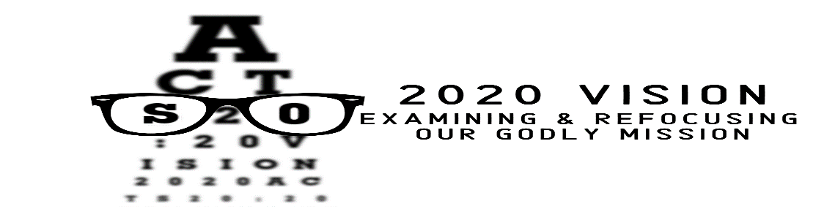

Pastor Tim Fillmore – Parkway Hills Church – January 19,2020

PURPOSE IS…
WHY ARE WE HERE?
WHAT ARE WE DOING?
WHAT SHOULD WE BE DOING?

Acts 20:20
“²⁰ You know that I have not hesitated to preach anything that would be helpful to you but have taught you publicly and from house to house.”

THE CHURCH EXISTS…

TO ______________ AND ____________________________!

1 John 1:9
“⁹If we confess our sins, he is faithful and just and will forgive us our sins and purify us from all unrighteousness.”

REASONS PEOPLE DON’T FORGIVE

____________________________

Colossians 3:13-14
“¹³Bear with each other and forgive whatever grievances you may have against one another. Forgive as the Lord forgave you. ¹⁴And over all these virtues put on love, which binds them all together in perfect unity.”

REASONS PEOPLE DON’T FORGIVE

____________________________

Luke 17:3-4
“³So watch yourselves. ‘If your brother sins, rebuke him, and if he repents, forgive him. ⁴If he sins against you seven times in a day, and seven times comes back to you and says, ‘I repent,’ forgive him.’”

REASONS PEOPLE DON’T FORGIVE

____________________________

2 Corinthians 5:17
“¹⁷Therefore, if anyone is in Christ, he is a new creation; the old has gone, the new has come!”

1 John 1:9-10
“⁹ If we confess our sins, he is faithful and just and will forgive us our sins and purify us from all unrighteousness. ¹⁰If we claim we have not sinned; we make him out to be a liar and his word has no place in our lives.”

REASONS PEOPLE SHOULD FORGIVE

____________________________

Acts 3:19
“¹⁹ Repent, then, and turn to God, so that your sins may be wiped out, that times of refreshing may come from the Lord.”

REASONS PEOPLE SHOULD FORGIVE

IT’S ____________________________

Proverbs 17:9
“⁹Whoever forgives an offense seeks love, but whoever keeps bringing up the issue separates the closest of friends.”

Ephesians 4:32
“³² Be kind and compassionate to one another, forgiving each other, just as in Christ God forgave you.”

REASONS PEOPLE SHOULD FORGIVE

IT’S ____________________________

Mark 11:25
“²⁵And when you stand praying, if you hold anything against anyone, forgive him, so that your Father in heaven may forgive you your sins.”

WHY FORGIVENESS AND THE CHURCH?

IT’S ____________________________!

Colossians 1:13-14
“¹³For he has rescued us from the dominion of darkness and brought us into the kingdom of the Son he loves, ¹⁴in whom we have redemption, the forgiveness of sins.”

Pastor Tim Fillmore – Parkway Hills Church – January 19,2020

PURPOSE IS…
WHY ARE WE HERE?
WHAT ARE WE DOING?
WHAT SHOULD WE BE DOING?

Acts 20:20
“²⁰ You know that I have not hesitated to preach anything that would be helpful to you but have taught you publicly and from house to house.”

THE CHURCH EXISTS…

TO ______________ AND ____________________________!

1 John 1:9
“⁹If we confess our sins, he is faithful and just and will forgive us our sins and purify us from all unrighteousness.”

REASONS PEOPLE DON’T FORGIVE

____________________________

Colossians 3:13-14
“¹³Bear with each other and forgive whatever grievances you may have against one another. Forgive as the Lord forgave you. ¹⁴And over all these virtues put on love, which binds them all together in perfect unity.”

REASONS PEOPLE DON’T FORGIVE

____________________________

Luke 17:3-4
“³So watch yourselves. ‘If your brother sins, rebuke him, and if he repents, forgive him. ⁴If he sins against you seven times in a day, and seven times comes back to you and says, ‘I repent,’ forgive him.’”

REASONS PEOPLE DON’T FORGIVE

____________________________

2 Corinthians 5:17
“¹⁷Therefore, if anyone is in Christ, he is a new creation; the old has gone, the new has come!”

1 John 1:9-10
“⁹ If we confess our sins, he is faithful and just and will forgive us our sins and purify us from all unrighteousness. ¹⁰If we claim we have not sinned; we make him out to be a liar and his word has no place in our lives.”

REASONS PEOPLE SHOULD FORGIVE

____________________________

Acts 3:19
“¹⁹ Repent, then, and turn to God, so that your sins may be wiped out, that times of refreshing may come from the Lord.”

REASONS PEOPLE SHOULD FORGIVE

IT’S ____________________________

Proverbs 17:9
“⁹Whoever forgives an offense seeks love, but whoever keeps bringing up the issue separates the closest of friends.”

Ephesians 4:32
“³² Be kind and compassionate to one another, forgiving each other, just as in Christ God forgave you.”

REASONS PEOPLE SHOULD FORGIVE

IT’S ____________________________

Mark 11:25
“²⁵And when you stand praying, if you hold anything against anyone, forgive him, so that your Father in heaven may forgive you your sins.”

WHY FORGIVENESS AND THE CHURCH?

IT’S ____________________________!

Colossians 1:13-14
“¹³For he has rescued us from the dominion of darkness and brought us into the kingdom of the Son he loves, ¹⁴in whom we have redemption, the forgiveness of sins.”

