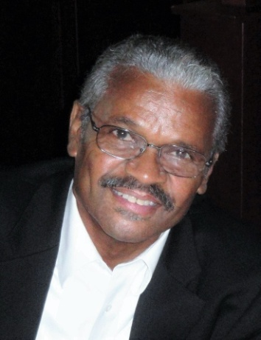

MINISTER JOHN SHERRWOOD HIRSCH
Minister John S. Hirsch was born in Memphis, Tennessee, to the late John W. Hirsch and Edna B. (Woodard) Hirsch. At age 4, Minister Hirsch lost his birth mother and in 1957 his father married Hannah (Gray) Hirsch who helped to raise him, along with his two brothers and a sister.
Minister Hirsch accepted his calling later in life on July 27, 2008 and was ordained on October 4, 2009 under the leadership of Pastor Leslie E. Stratton at Rockland Missionary Baptist Church. This path has led him in the same direction as his grandfather, the Reverend Sydney Woodard, Sr. who once was Pastor of East Trigg Missionary Baptist Church in Memphis, Tennessee.
He is an anointed teacher, preacher, and a child of God whose faith in God stands strong. As a servant for the Lord, Minister Hirsch is an Associate Minister, the Youth Advisor, Mission and Outreach Ministry Leader, and a Sunday School Teacher. He has served in various capacities with the youth for over 35 years and has developed the Youth Faith Initiative Program and the Pennies from Heaven Program to teach our youth about the kind of faith needed to be committed to any endeavor. He has been instrumental in organizing various Rockland Outreach Programs over the years.
After graduating from Manassas High School in 1969, Minister Hirsch earned a Bachelor of Arts Degree in Education in 1973 at Langston University, Langston, Oklahoma. Later, he earned his degree in Air Conditioning – Refrigeration in 1992 and is Board Certified. With the desire to further study in the religious field, he has earned a Masters in Christian Studies in 2011 from Union University of Jackson, Tennessee.
Minister Hirsch married his college sweetheart, Joan B. Battle in 1974. They have one son, Brandon Christopher Hirsch, an actor, and a loving and caring daughter-in-law, Erica and the family's pride and joy, two granddaughters, Ayla Rose and Lennon Alexandria and a new grandson, Lachland Christopher, born in April 2019.
As Minister Hirsch has always remembered his childhood with wonderful Christian parents, his first sermon was on August 31, 2008 and the title was Being Raised in the Way of the Lord. His Christian experience as a child provided him with a passion for children growing in Christ. His mission is committing to the youth program, to nurture and provide them with spiritual experiences and to teach them to evangelize and become missionaries, whether it is locally or abroad.
As a Servant for the Lord, Minister Hirsch has been instrumental in organizing the Rockland church's Nashville Rescue Mission Outreach for sixteen consecutive years, the Men's Outreach Recovery Program and the Food Pantry Program.
With the youth, two of our youth have had the opportunity to go on a mission trip to the Dominican and our main project has been several Convoy of Hope trips. Also, Minister Hirsch has been a part of the team which helped to organize our Church Boy Scout Troop.
As a licensed and reputable Heating and Air Contractor, Minister Hirsch, through his heating and air company, has either directly or indirectly provided resources that have allowed many elderly individuals to receive Heating and Air Conditioning, many for the first time in their lives. Throughout his daily work, he has had many opportunities upon request to pray with others.

