Shepherd of the Valley Lutheran Church
A congregation of the Lutheran Church - Missouri Synod (LCMS)
4510 North River Road Oceanside, California 92057 Office Phone: 760.433.9250
Pastor: Dr. Allen Kolkman Home: 760.433.4885 Cell: 760.805.7376
Website: www.svlchurch.org Email: KolkmanAllen@gmail.com
Mailing Address: PO Box 406 San Luis Rey, CA 92068

Shepherd of the Valley Lutheran Church is a Christ-centered family dedicated to reaching out to
our community, teaching God’s Word, caring for one another and sharing God’s genuine love.

October 4, 2020

Health Request: As we seek to protect the health of others and ourselves, please seat yourself and your family at least 6 feet away from others; and please wear a mask when you are speaking and singing, during fellowship, and when you could be within 6 feet of others. Thank you for your cooperation!

To Our Guests: Welcome to Shepherd of the Valley Lutheran Church! We are so glad to have you with us this morning, celebrating His great love and dedicating ourselves anew to Him! We hope you’ll be blessed and that you’ll return and worship among us again. Please take a moment to complete the welcome card in the packet you received and give it to the Greeter or Pastor after the service. Thank you!

The Sacrament of Holy Communion is celebrated every Sunday. We recommend that you speak with the pastor beforehand if you have never participated in Communion at Shepherd of the Valley and that children participate in classes and have parental authorization before participating. For maximum sanitation, we are temporarily using sealed sets. Questions? Please speak with the pastor.

Sunday Study Time! 9:00 in person in the Community Building and also streamed online at https://us02web.zoom.us/j/86292069694 for those practicing in-home isolation or away. By popular request, we are studying the Augsburg Confession from the perspective of Scripture.

Painting Class It’s next Sunday October 11 at 12:00 Noon. For more information or to register, go to www.pamscolorpallet.com

GOODIES! Yup, refreshments return to our Fellowship time after worship! But the Covid guidelines continue: Practice physical distancing with non-relatives and wear a mask except when eating/drinking. Thank you! And thanks to our hostess today, Elizabeth Santiago!
Property Improvement Event is this Saturday, 10:00 – Noon. Gardening, cleaning, improvements – something for all ages and abilities. Questions? Contact Bruce at bruce_woodward@hotmail.com

Did You Know? We have a church library. It’s at the back of the chapel. Lots of great books that are biblically and theologically sound, books that are informational, inspirational and helpful. It’s on “the honor system.” K Berni is the librarian Questions? Email her at kberni@aol.com

+ The Eighteenth Sunday after Pentecost +

Before the Service

The Welcome

The Announcements See page 1

The Service of the Word

The Prelude and Silent Personal Prayer

The Opening Song “Stand Up, Stand Up”

Stand up, stand up for Jesus, Ye soldiers of the cross.
Lift high His royal banner; It must not suffer loss.
From vict’ry unto vict’ry His army He shall lead
Till ev’ry foe is vanquished, And Christ is Lord indeed.

Stand up, stand up for Jesus; The trumpet call obey;
Stand forth in mighty conflict In this His glorious day.
Let all His faithful serve Him Against unnumbered foes;
Let courage rise with danger And strength to strength oppose.

Stand up, stand up for Jesus; The strife will not be long;
This day the din of battle, The next the victor’s song.
The soldiers, overcoming, Their crown of life shall see
And with the King of Glory Shall reign eternally.

The Opening Responses:

In the name of the Father and the Son and the Holy Spirit +
Gathered as His sons and daughters, redeemed by Christ!

If we say we have no sin, we deceive ourselves and the truth is not in us. But if we confess our sins, our God, who is faithful and just, will forgive our sins in Christ and cleanse us from all unrighteousness.

We confess to You that we are sinful and unclean and that we have sinned against You in thought, word and deed. We have not loved You with our whole heart and we have not loved others as You have loved us. We deserve Your present and eternal punishment. For the sake of Your Son, Jesus Christ, forgive us, renew us and lead us, so that we may delight in Your will and walk in Your ways, to the glory of Your name.
Our heavenly Father has had mercy on us and has given us His only Son to die for us. In Christ, He forgives us all our sins.
Thanks be to God!

Let us speak of the glory of our God! Let us tell of His wonderful grace!
Let us rejoice in the victory of Christ, let us celebrate the victory of salvation!

The Praise Song: “Come, Thou Fount”

Come, Thou Fount of ev’ry blessing,
Tune my heart to sing Thy grace;
Streams of mercy, never ceasing,
Call for songs of loudest praise.
While the hope of endless glory
Fills my heart with joy and love,
Teach me ever to adore Thee;
May I still Thy goodness prove.

The First Lesson: Isaiah 5:1-7 ESV

Let me sing for my beloved my love song concerning his vineyard: My beloved had a vineyard on a very fertile hill. He dug it and cleared it of stones, and planted it with choice vines; he built a watchtower in the midst of it, and hewed out a wine vat in it; and he looked for it to yield grapes, but it yielded wild grapes. And now, O inhabitants of Jerusalem and men of Judah, judge between me and my vineyard. What more was there to do for my vineyard, that I have not done in it?
When I looked for it to yield grapes, why did it yield wild grapes? And now I will tell you what I will do to my vineyard. I will remove its hedge, and it shall be devoured; I will break down its wall, and it shall be trampled down. I will make it a waste; it shall not be pruned or hoed, and briers and thorns shall grow up; I will also command the clouds that they rain no rain upon it. For the vineyard of the Lord of hosts is the house of Israel, and the men of Judah are his pleasant planting;
and he looked for justice, but behold, bloodshed for righteousness, but behold, an outcry! This is the Word of the Lord. Thanks be to God! .

The Psalmody: From Psalm 80

O Lord, look down upon us
Come and save us, good Lord!

Show us your mercy!
Come and save us, good Lord!

Show us your strength!
Come and save us, good Lord!

The Second Lesson: Philippians 3:4-14 ESV

If anyone else thinks he has reason for confidence in the flesh, I have more: circumcised on the eighth day, of the people of Israel, of the tribe of Benjamin, a Hebrew of Hebrews; as to the law, a Pharisee; as to zeal, a persecutor of the church; as to righteousness under the law, blameless. But whatever gain I had, I counted as loss for the sake of Christ. Indeed, I count everything as loss because of the surpassing worth of knowing Christ Jesus my Lord. For his sake I have suffered the loss of all things and count them as rubbish, in order that I may gain Christ and be found in him, not having a righteousness of my own that comes from the law, but that which comes through faith in Christ, the righteousness from God that depends on faith— that I may know him and the power of his resurrection, and may share his sufferings, becoming like him in his death, that by any means possible I may attain the resurrection from the dead. This is the Word of the Lord. Thanks be to God! .

The Gospel Lesson: St. Matthew 21:33-46 ESV Please Stand

(Jesus said) “Hear another parable. There was a master of a house who planted a vineyard and put a fence around it and dug a winepress in it and built a tower and leased it to tenants, and went into another country. When the season for fruit drew near, he sent his servants to the tenants to get his fruit. And the tenants took his servants and beat one, killed another, and stoned another. Again he sent other servants, more than the first. And they did the same to them. Finally he sent his son to them, saying, ‘They will respect my son.’ But when the tenants saw the son, they said to themselves, ‘This is the heir. Come, let us kill him and have his inheritance.’ And they took him and threw him out of the vineyard and killed him. When therefore the owner of the vineyard comes, what will he do to those tenants?” They said to him, “He will put those wretches to a miserable death and let out the vineyard to other tenants who will give him the fruits in their seasons.” Lord, have mercy on us. Thanks be to God! .

The Affirmation of Faith: The Nicene Creed (AD 325)

We believe in one God, the Father Almighty, maker of heaven and earth, and of all things - visible and invisible.

And in one Lord Jesus Christ, the only-begotten Son of God, begotten of His Father before all worlds, God of God, Light of Light, true God of true God, begotten, not made, being of one substance with the Father, by whom all things were made; and who for us and for our salvation, came down from heaven and was incarnate by the Holy Spirit of the Virgin Mary and was made man; and was crucified for us under Pontius Pilate. He suffered, and was buried. And on the third day He rose according to the Scriptures and ascended into heaven and sits on the right hand of the Father. And He will come again with glory to judge both the living and the dead; His Kingdom will have no end.

We believe in the Holy Spirit, the Lord and Giver of Life, who proceeds from the Father and the Son, who with the Father and the Son together is worshiped and glorified, who spoke by the prophets.

And we believe in one holy catholic and apostolic church, we acknowledge one Baptism for the forgiveness of sins, we look for the resurrection of the dead and the life of the world to come. Amen!

The Children’s Message:

The Song of the Day: “Jesus, Name Above All Names”

Jesus, name above all names
Beautiful Savior, Glorious Lord
Emmanuel, God is with us
Blessed Redeemer, Living Word
Jesus, loving shepherd Vine of the branch's
Son of God
Prince of peace, wonderful counselor
Lord of the universe, Light of the world.

Jesus, way of salvation
King of kings, Lord of lords
The way, the truth, and the life
Mighty creator, my Savior and friend.

The Message: “Christ, the Builder”

Text – I appeal to you, brothers, by the name of our Lord Jesus Christ, that all of you agree, and that there be no divisions among you, but that you be united in the same mind and the same judgment. First Corinthians 1:10

Going back to the beginning, we celebrate that Christ ______ us! God gave us physical _______ (typically using tools) and He gave us spiritual _______, faith (typically using tools).

But He didn’t so much make us as separate, individual, independent people – He set us into families – our earthly __________ and our __________ one (the family of God, the Church). We’re in this _______________.

And this is for a ____________. We are to ________ (Great Commandment) and to ______________ (Great Commission).

Reflections:

- In the Creed every week, we proclaim that GOD is the “Lord and giver of life.” We’re thinking especially of faith and spiritual life (God GIVES it, we don’t TAKE it; He gives us, not offers it) But does this apply to physical life, too?

- The pastor said God typically uses “tool” to GIVE life, to bring us into existence as people and then as Christians. What “tools” did God use to give you faith? Are their people, hymns, events you can think of?

- We live in a culture of EXTREME individualism. How can that badly impact life, including our spiritual life and ministry?

The Prayers: Please stand

Altar Prayer

Congregation Petitions

The Lord’s Prayer:

Our Father who art in heaven, hallowed be Thy name; Thy Kingdom come, Thy will be done on earth as it is in heaven. Give us this day our daily bread, and forgive us our trespasses as we forgive those who trespass against us. And lead us not into temptation but deliver us from evil. For Thine is the Kingdom and the power and the glory forever and ever. Amen!

The Service of Holy Communion

The Invitation: Please stand

Disciples of the Lord, come to receive our Savior.
We come to receive His true body and blood in this holy Sacrament.
We praise You, O Lord, for having had mercy on us and giving us Your only begotten Son, that whoever trusts in Him will not perish but has everlasting life.
Send Your Spirit into our hearts that He may strengthen our faith and prepare us to joyfully remember and receive our Savior who comes to us in His body and blood

The Institution: Please stand

The Peace:

The peace of the Lord be with you!
And also with you!

The Lamb of God: Please stand
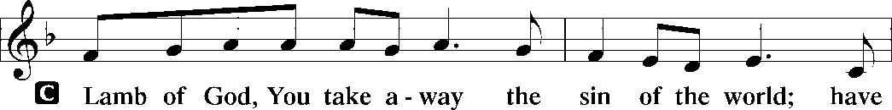
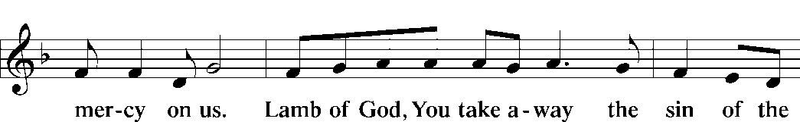
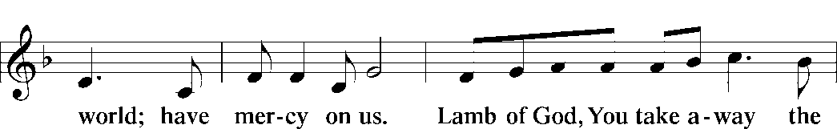
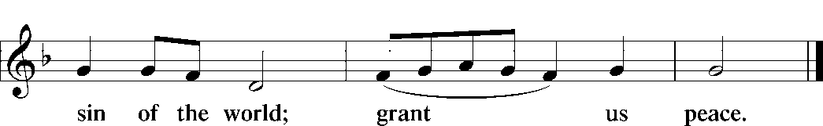

The Reception: See announcements on page one

The Thanksgiving:

We praise You, O Lord, for having fed us with the Body and Blood of our Savior, Jesus Christ – forgiving us, assuring us and strengthening us.
By Your Holy Spirit, help us continue in the fellowship of faith and thank You by the good works that You desire.

The Benediction: Please stand

The Lord bless you and keep you.
The Lord make His face shine upon you and be gracious to you.
The Lord look upon you with favor and give you peace +
Amen!

The Closing Song: “Ye Watchers”

Ye watchers and ye holy ones,
Bright seraphs, cherubim, and thrones,
Raise the glad strain: “Alleluia!”
Cry out, dominions, princedoms, pow’rs,
Virtues, archangels, angels’ choirs:
“Alleluia, alleluia! Alleluia, alleluia, alleluia!”

O friends, in gladness let us sing,
Supernal anthems echoing:
“Alleluia, alleluia!”
To God the Father, God the Son,
And God the Spirit, Three in One:
“Alleluia, alleluia! Alleluia, alleluia, alleluia!”

Fellowship and refreshments follows outside! Just remember that “physical distancing” thing still applies and please wear your masks when not eating or drinking. Thank you!

All songs and hymns: Used by permission LSB Hymn License NET # 100011480 or CCLI license # 2021603

Guidelines for Congregational Prayer

Litany prayer is very ancient form of public, corporate prayer.

The worship leader leads general prayers and then invites individual worshippers to add these petition(s) in the form of a litany. They are SHORT (one brief sentence; a dozen words or so max), to-the-point, requests or praise/thanksgivings which are ended with the petitioner saying: “Lord, in Your mercy.” To which the whole congregation replies: “Hear our prayer.” This continues for as long as the worship leader senses we’ve lifted up all desired petitions (forgive him if he cuts you off!).

If you don’t want to do this publicly, request the pastor to include your petition in his altar prayer; just speak to him BEFORE the worship service and so request.

In offering such petitions, please keep the following in mind:

+ Beware of revealing things about another which that person may feel is private (Sometimes, just leaving out the name helps a lot).
+ Please do not use last names.
+ Beware of information-giving; litany petitions are not information but requests or praise.
+ Beware of making them too long (they are short – one brief sentence, likely less than a dozen words).
+ You may offer more than one petition, but please keep them separate.
+ Speak up so all can hear.

Good examples:

+ “Strengthen and heal my neighbor; Lord, in Your mercy”
+ “Bless my search for employment; Lord, in Your mercy”
+ “Thank You for all Your blessings; Lord, in Your mercy”
+ “Give me focus and insight for my studies; Lord, in Your mercy”
+ “Grant healing to my foot; Lord, in Your mercy”
+ “Comfort my coworker in his grief; Lord, in Your mercy”
+ “Thank You, Lord, for healing; Lord in Your mercy”
+ “Strengthen my faith and commitment that I may do Your will; Lord, in Your mercy”
+ “Make my life more reflective of Your love and will; Lord, in Your mercy”
+ “Make me an effective teacher to a boy in my class; Lord, in Your mercy”

NEED HELP? Ask the pastor before the service; he’ll help you!

We’d love to include this prayer in our daily prayers, just email the pastor at KolkmanAllen@gmail.com and we’ll include it.

Praise Song: (NOTE: We’ll use this throughout the Summer)

1 Come, Thou Fount of ev’ry blessing,
Tune my heart to sing Thy grace;
Streams of mercy, never ceasing,
Call for songs of loudest praise.
While the hope of endless glory
Fills my heart with joy and love,
Teach me ever to adore Thee;
May I still Thy goodness prove.

