Shepherd of the Valley Lutheran Church
A congregation of the Lutheran Church - Missouri Synod (LCMS)
4510 North River Road Oceanside, California 92057 Office Phone: 760.433.9250
Pastor: Dr. Allen Kolkman Home: 760.433.4885 Cell: 760.805.7376
Website: www.svlchurch.org Email: KolkmanAllen@gmail.com
Mailing Address: PO Box 406 San Luis Rey, CA 92068

Shepherd of the Valley Lutheran Church is a Christ-centered family dedicated to reaching out to
our community, teaching God’s Word, caring for one another and sharing God’s genuine love.

September 20, 2020

Covid 19 Mandates As we seek to protect the health of others and ourselves, please seat yourself and your family at least 6 feet away from others, and please wear a mask at least when you are speaking and singing, during fellowship, and also when you could be within 6 feet of others. Thank you for your cooperation!

To Our Guests: Welcome to Shepherd of the Valley Lutheran Church! We are so glad to have you with us this morning, celebrating His great love and dedicating ourselves anew to Him! We hope you’ll be blessed and that you’ll return and worship among us again. Please take a moment to complete the welcome card in the packet you received and give it to the Greeter or Pastor after the service. Thank you!

The Sacrament of Holy Communion is celebrated every Sunday. We recommend that you speak with the pastor beforehand if you have never participated in Communion at Shepherd of the Valley and that children participate in classes and have parental authorization before participating. For maximum sanitation, we are temporarily using sealed sets. Questions? Please speak with the pastor.

Sunday Study Time! 9:00 in person in the Community Building and also streamed online at https://us02web.zoom.us/j/ 86292069694 for those practicing in-home isolation or away. By popular request, we are studying the Augsburg Confession from the perspective of Scripture. Please join us!

Painting Class Sign-ups have begun for the next session: It’s Sunday October 11 (note new date), 12:00 Noon. For more information or to register, go to www.pamscolorpallet.com

“Wine on the Patio” online fellowship, this Friday, 5:00 - 6:00, at https://us02web.zoom.us/j/93132423436 Lori Dowe is the webmaster and the hostess; for more information, contact her at loridowe@gmail.com

Did You Know? We have a church library. It’s at the back of the chapel. Lots of great books that are biblically and theologically sound, books that are informational, inspirational and helpful. It’s on “the honor system.” K Berni is the librarian Questions? Email her at kberni@aol.com

+ The Sixteenth Sunday after Pentecost +

Before the Service

The Welcome

The Announcements See page 1

The Service of the Word

The Prelude and Personal Prayer

The Opening Song “Immortal, Invisible”

Immortal, invisible, God only wise,
In light inaccessible hid from our eyes,
Most blessèd, most glorious, the Ancient of Days,
Almighty, victorious, Thy great name we praise.

Great Father of glory pure Father of light,
Thine angels adore Thee, all veiling their sight;
All laud we would render: O help us to see
’Tis only the splendor of light that hides Thee.

The Opening Responses:

In the name of the Father and the Son and the Holy Spirit +
Gathered as His sons and daughters, redeemed by Christ!

If we say we have no sin, we deceive ourselves and the truth is not in us. But if we confess our sins, our God, who is faithful and just, will forgive our sins in Christ and cleanse us from all unrighteousness.

We confess to You that we are sinful and unclean and that we have sinned against You in thought, word and deed. We have not loved You with our whole heart and we have not loved others as You have loved us. We deserve Your present and eternal punishment. For the sake of Your Son, Jesus Christ, forgive us, renew us and lead us, so that we may delight in Your will and walk in Your ways, to the glory of Your name.
Our heavenly Father has had mercy on us and has given us His only Son to die for us. In Christ, He forgives us all our sins.
Thanks be to God!

Let us speak of the glory of our God! Let us tell of His wonderful grace!
Let us rejoice in the victory of Christ, let us celebrate the victory of salvation!

The Praise Song: “Come, Thou Fount”

Come, Thou Fount of ev’ry blessing,
Tune my heart to sing Thy grace;
Streams of mercy, never ceasing,
Call for songs of loudest praise.
While the hope of endless glory
Fills my heart with joy and love,
Teach me ever to adore Thee;
May I still Thy goodness prove.

The First Lesson: Isiah 55:6-9 ESV

“Seek the Lord while he may be found; call upon him while he is near; let the wicked forsake his way, and the unrighteous man his thoughts; let him return to the Lord, that he may have compassion on him, and to our God, for he will abundantly pardon. For my thoughts are not your thoughts, neither are your ways my ways, declares the Lord. For as the heavens are higher than the earth, so are my ways higher than your ways and my thoughts than your thoughts.” This is the Word of the Lord. Thanks be to God! .

The Psalmody: From Psalm 27
The Lord makes me secure on a high rock!
The Lord is my savior!

The Lord shelters me!
The Lord is my savior!

Others may fail but I trust in the Lord always!
The Lord is my savior!

The Second Lesson: Philippians 1:12-14, 19-30 ESV

I want you to know, brothers, that what has happened to me has really served to advance the gospel, so that it has become known throughout the whole imperial guard and to all the rest that my imprisonment is for Christ. And most of the brothers, having become confident in the Lord by my imprisonment, are much more bold to speak the word without fear…. Yes, and I will rejoice, for I know that through your prayers and the help of the Spirit of Jesus Christ this will turn out for my deliverance, as it is my eager expectation and hope that I will not be at all ashamed, but that with full courage now as always Christ will be honored in my body, whether by life or by death. For to me to live is Christ, and to die is gain. If I am to live in the flesh, that means fruitful labor for me. Yet which I shall choose I cannot tell. I am hard pressed between the two. My desire is to depart and be with Christ, for that is far better. But to remain in the flesh is more necessary on your account. Convinced of this, I know that I will remain and continue with you all, for your progress and joy in the faith, so that in me you may have ample cause to glory in Christ Jesus, because of my coming to you again. Only let your manner of life be worthy of the gospel of Christ, so that whether I come and see you or am absent, I may hear of you that you are standing firm in one spirit, with one mind striving side by side for the faith of the gospel, and not frightened in anything by your opponents. This is a clear sign to them of their destruction, but of your salvation, and that from God. For it has been granted to you that for the sake of Christ you should not only believe in him but also suffer for his sake, engaged in the same conflict that you saw I had and now hear that I still have. This is the Word of the Lord. Thanks be to God! .
The Gospel Lesson: St. Matthew 20:1-16 ESV Please Stand

(Jesus said) “For the kingdom of heaven is like a master of a house who went out early in the morning to hire laborers for his vineyard. After agreeing with the laborers for a denarius a day, he sent them into his vineyard. And going out about the third hour he saw others standing idle in the marketplace, and to them he said, ‘You go into the vineyard too, and whatever is right I will give you.’ So they went. Going out again about the sixth hour and the ninth hour, he did the same. And about the eleventh hour he went out and found others standing. And he said to them, ‘Why do you stand here idle all day?’ They said to him, ‘Because no one has hired us.’ He said to them, ‘You go into the vineyard too.’ And when evening came, the owner of the vineyard said to his foreman, ‘Call the laborers and pay them their wages, beginning with the last, up to the first.’ And when those hired about the eleventh hour came, each of them received a denarius. Now when those hired first came, they thought they would receive more, but each of them also received a denarius. And on receiving it they grumbled at the master of the house, saying, ‘These last worked only one hour, and you have made them equal to us who have borne the burden of the day and the scorching heat.’ But he replied to one of them, ‘Friend, I am doing you no wrong. Did you not agree with me for a denarius? Take what belongs to you and go. I choose to give to this last worker as I give to you. Am I not allowed to do what I choose with what belongs to me? Or do you begrudge my generosity?’ So the last will be first, and the first last.” Lord, have mercy on us. Thanks be to God! .

7

The Affirmation of Faith: The Nicene Creed (AD 325)

We believe in one God, the Father Almighty, maker of heaven and earth, and of all things - visible and invisible.

And in one Lord Jesus Christ, the only-begotten Son of God, begotten of His Father before all worlds, God of God, Light of Light, true God of true God, begotten, not made, being of one substance with the Father, by whom all things were made; and who for us and for our salvation, came down from heaven and was incarnate by the Holy Spirit of the Virgin Mary and was made man; and was crucified for us under Pontius Pilate. He suffered, and was buried. And on the third day He rose according to the Scriptures and ascended into heaven and sits on the right hand of the Father. And He will come again with glory to judge both the living and the dead; His Kingdom will have no end.

We believe in the Holy Spirit, the Lord and Giver of Life, who proceeds from the Father and the Son, who with the Father and the Son together is worshiped and glorified, who spoke by the prophets.

And we believe in one holy catholic and apostolic church, we acknowledge one Baptism for the forgiveness of sins, we look for the resurrection of the dead and the life of the world to come. Amen!

The Children’s Message:

The Song of the Day: “Amazing Grace”

Amazing grace—how sweet the sound— That saved a wretch like me!
I once was lost but now am found, Was blind but now I see!

Through many dangers, toils, and snares I have already come;
His grace has brought me safe thus far, His grace will lead me home.

Yes, when this flesh and heart shall fail And mortal life shall cease,
Amazing grace shall then prevail In heaven’s joy and peace.

The Message: “Fair vs. Mercy” Text – Gospel reading on page 5

There are really only two religions in the world: The religion of ___________ and the religion of ___________. Most people (even some Christians!) hold to the religion of _______.

When the men who worked the longest learned that the ones who hardly worked at all were paid the ________, they were not too _______. But Jesus gives His (common) “Gospel Twist” turning the story into one embracing the religion of ________.

Some don’t understand the assignment. God requires NOT that we try harder than the bozo next door, NOT that we really want something, NOT that we be sincere but that we be _____________.

So, if God operated under the principle of fairness, we’ll all be in a LOT of _________. But we rejoice in the Gospel, God treats us according to the principle of ___________. Not as our merits suggest but as His _______ suggests. We rejoice that God is NOT ________ but rather _______________.

Reflections:

- Jesus’ parables often suggest that we place ourselves in the story… If Jesus were a casting director and His parable a play, where would He cast YOU? Why?

- There’s often a surprising twist in Jesus’ parables… a twist that is often His point! Where is the twist in this parable? How is it His point?

- Hoping God is FAIR is based on the idea that who is great? Hoping that God is merciful is based on the idea that who is great?

The Prayers: Please stand

Altar Prayer

Congregation Petitions

The Lord’s Prayer:

Our Father who art in heaven, hallowed be Thy name; Thy Kingdom come, Thy will be done on earth as it is in heaven. Give us this day our daily bread, and forgive us our trespasses as we forgive those who trespass against us. And lead us not into temptation but deliver us from evil. For Thine is the Kingdom and the power and the glory forever and ever. Amen!

The Service of Holy Communion

The Invitation: Please stand

Disciples of the Lord, come to receive our Savior.
We come to receive His true body and blood in this holy Sacrament.
We praise You, O Lord, for having had mercy on us and giving us Your only begotten Son, that whoever trusts in Him will not perish but has everlasting life.
Send Your Spirit into our hearts that He may strengthen our faith and prepare us to joyfully remember and receive our Savior who comes to us in His body and blood

The Institution: Please stand

The Peace:

The peace of the Lord be with you!
And also with you!

The Lamb of God: Please stand
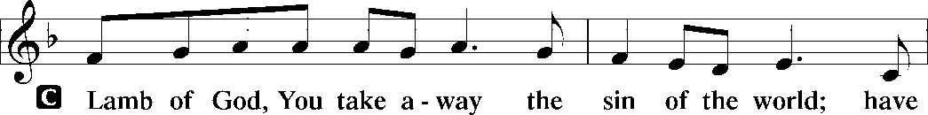
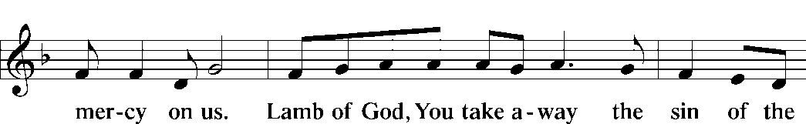
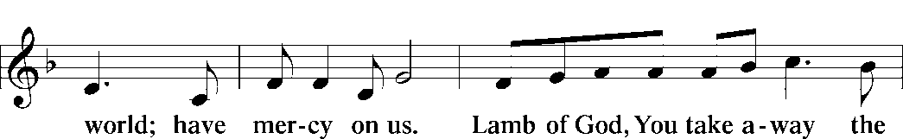
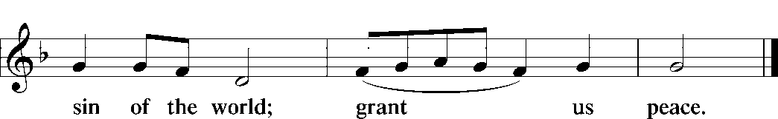

The Distribution: See announcements on page one

The Thanksgiving:

We praise You, O Lord, for having fed us with the Body and Blood of our Savior, Jesus Christ – forgiving us, assuring us and strengthening us.
By Your Holy Spirit, help us continue in the fellowship of faith and thank You by the good works that You desire.

The Benediction:

The Lord bless you and keep you.
The Lord make His face shine upon you and be gracious to you.
The Lord look upon you with favor and give you peace +
Amen!

The Closing Song: “You Are the Way”

You are the way; through You alone Can we the Father find;
In You, O Christ, has God revealed His heart and will and mind.

You are the truth; Your Word alone True wisdom can impart;
You only can inform the mind And purify the heart.

You are the life; the empty tomb Proclaims Your conqu’ring arm,
And those who put their trust in You Not death nor hell shall harm.

You are the way, the truth, the life; Grant us that way to know,
That truth to keep, that life to win Whose joys eternal flow.

All songs and hymns: Used by permission LSB Hymn License NET # 100011480 or CCLI license # 2021603

