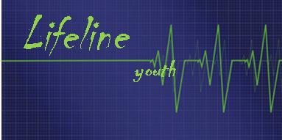

**2016**

**Tri-Fete-athon**

August 28 Open Gym

Sept 4 Blendon Woods or Laser Tag

Sept. 10 Buckeye Watch - 3pm – 6pm

**Regular Meetings begin**

Sept. 18

Sept. 20-21 Possible Leader retreat

Sept. 25

Oct. 2

Oct. 9

Oct. 16

Oct. 23

Oct. 30 Trunk or Treat

Nov. 6

Nov. 13

Nov. 20

Nov. 27 Hanging of the Greens

Dec. 4

Dec. 10 Christmas Party

Mar. 12

Mar. 19

**2017**

Jan. 8

Jan. 15

Jan. 22

Jan. 27-29 Marmon Valley Retreat

Feb. 5

Feb. 12

Feb. 19 Movie night

Feb 26

Mar. 5

Mar. 12

Mar. 19

March 26 No youth Group

**Spring Break**

March 27-31 Confirmation Trip

April 2

April 9 Prayer Path

April 16 Easter Egg Hunt at church

April 23

April 30

May 7

May 13 Senior Send off

**Youth Group 2016-2017 Calendar**

**Sunday evenings: 5 pm to 7pm**

thhour