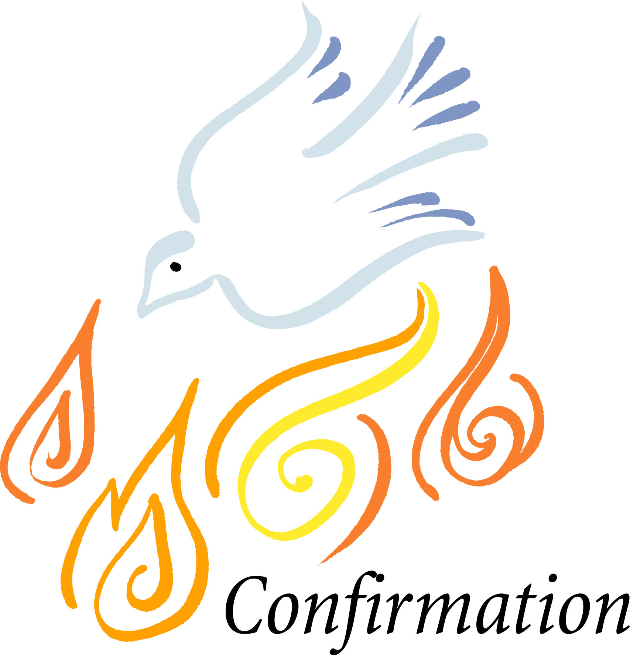

Oct. 1 Opening Session: Saturday from 4 – 5:30

Oct. 8

Oct. 15

Oct. 22

Oct. 29

Nov. 5

Nov. 12 Service Project

Nov. 19-20 Retreat to Marmon Valley

Break

Nov. 26- Dec. 28 Focus on attending Sunday School, participating in the ministry of the church through attendance or service with:

Hanging of the Greens, Children’s musical, Christmas Eve worship, Christmas camp for children

Jan. 7

Jan. 14

Jan. 21

Jan. 28

Feb. 4

Feb. 11

Feb. 18 Service project

Mar. 9 Prayer Path – prepare a station and guide

Mar. 27-31 Confirmation Trip

April 22 Confirmation Service for parents and mentors

April 23 Confirmation Sunday

Summer Mission events:   T-Zone July 9-14

**2016-2017**