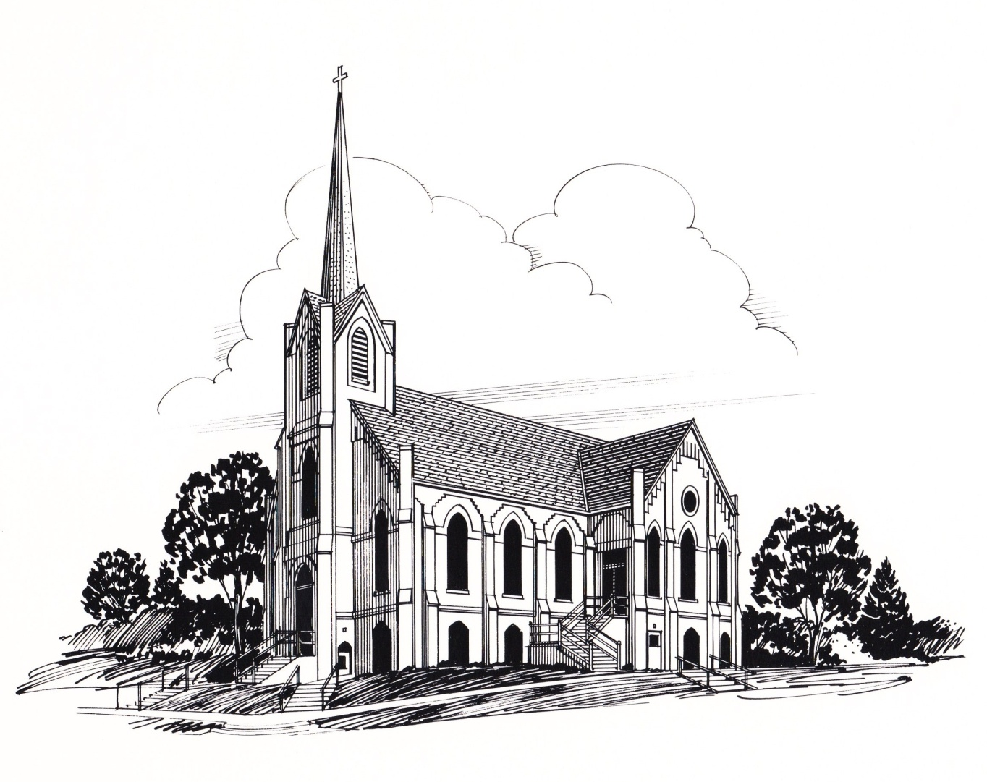D:\Tess Johnson\Downloads\column_10082.tif

### Inside This Issue

Pastor’s Column 1

Announcements 2

Poinsettia Listing 3

Baptism Announcement 4

Birthdays and Anniversaries 4

Altar Committee & Sewing Meetings 5

Sunday School, W.O.W., Dorcas Society 5

The Calendar 6

Church Council 7

Prayers of Concern 8

Ushers, Greeters, Acolytes, 9

Video, Sound & Organists 9

Christian Humor to Tickle Your Life 10

The Christmas season is a special season of the year, filled with beautiful lights and decorations, and the singing of carols. Yet, as wonderful as it is, Christmas day arrives and then it is gone, and soon the lights and decorations come down, and the sound of the carols fade. As this happens we may find ourselves felling empty as the blessing of the season seems to be past.

However, this is where the good news of Christmas can have its effect. For as we enter the new year we can remember that just as Jesus entered our world and lived among us, he can still be with us through his Holy Spirit.

As we trust in Jesus, we can live in a daily relationship with him and experience his presence. In this relationship we can also know our times and future are in his hands and this can give us peace.

Thus, as we enter the new year may we remember that in his coming, Jesus would enable us to experience his presence and peace.

God bless,

Pastor Mark

We would like to thank everyone for their Christmas greetings, cards, and gifts this past Christmas season. Your thoughtfulness and kindness is very much appreciated. It is a blessing to serve among you. We hope and trust you had a nice Christmas and may you have a blessed new year.

Sincerely,

Mark and Jacque

January 2015

Volume 3, Issue 1

THE SPIRE

By Rev. Mark Eldal

###### First Ev. Lutheran Church,201 N. Davis, PO Box 152 ,Oakland, NE, 68045

###### [www.firstlutheranchurch-oakland.com](http://www.firstlutheranchurch-oakland.com), [firstlutheranchurch\_152@q.com](mailto:firstlutheranchurch_152@q.com) (402) 685-5764



# **ANNOUNCEMENTS**

**Winter Coat Drive.** **The Women of the Word (WOW)** are planning a winter coats, mittens, and hats drive. We are going to try to keep these items in the area as there is a desperate need here. Please bring all gently used coats in any size, hats and mittens or gloves.

**Come one, Come All!!** Help is needed to take down the Christmas Decorations at the church on Saturday January 10th, 2015 at 9:00 a.m.



**All information needed for each committee's annual reports** needs to be turned into Tess in the office by January 10, 2013 to make it into the Annual Report.

**The offering envelopes** for the 2015 year are located in the multipurpose room. Please take them home with you.

**D:\Tess Johnson\Downloads\meet6.tif**

**The Annual Meeting will be held January 26th, at 10:45 a.m. with a Soup Dinner to follow.**

**Please contact Tara Miller, Darrell Denker or Travis Thomsen** if you are interested in participating in any of the church committees.

**On behalf of the WOW Groups, Hannah, Mary and Ruth, we would like to thank Patty Miller** for her past years as coordinator. The Executive Officers will meet at 9:00 a.m. at church on the Mondays prior to the group meetings on Wednesdays this year. Thank you to the leaders and assistans who have gacioulsy consented to server. Karen Rosenboom, Coordinator 2015

**We thank everyone who has contributed their talents to our Christmas Eve worship service:**

* Hannah Hyslop for her children's sermon.
* Jim and Judy Nelson for presenting the service on the screen.
* Jenna Bromm, Zoe Linder, Mia Linder and Gabi Linder for their singing.
* The Choir for their song.
* Zak Liermann and Jared Mulder for their trumpet accompaniment.
* Bryan Bohn for directing the Choir.
* Cindy Blanc for her accompaniment with the piano.
* Billye Pearson and Bryan Bohn for being the organists.
* Dan Tanksley for operating the sound system.
* All others who have assisted with our Christmas Eve Services.

**Thank you to everyone who donated poinsettia to beautify our Church for Christmas! They are as listed below:**

**In Memory of:**

* Jacob Johnson, Wilbert Voss and Harry Goodrich by Mark & Jill Johnson
* Loved Ones by Tom & Phyllis Meyer
* Elroy and Eunice Johnson, Carolyn Johson & Loved Ones by Larry, Tess Johnson & family
* Joesph Forks, Fern Forks and Myron and Sybel Slatt by Ed & Vivian Forks
* Bill Voss, Harry Goodrich and Jacob Johnson by Bonnie Goodrich
* Our Parents and other family members by Ken & Billye Pearson
* Mr. & Mrs. Virgil Lane, Mr. & Mrs. Albert C. Johnson, Mr. & Mrs. Otto Dinklage by John & Chloe Johnson
* Vernon K & Lillian Johnson by Richard & Janet Reckmeyer and Glenn & Sharon Krueger
* Rolland and Edla Anderson by Larry Dean Anderson
* Garrett Jay Frahm and Cynthia L. Peterson by Charles and Clara Frahm
* Brad Peterson and our service men and women by Lee and Sharon Peterson
* Garland Erickson by Florence Erickson
* Dr. Harold Blanc and Herb Begeman by Max & Cindy Blanc and Family
* Bob Lindstrom by Marlene Lindstrom and Family
* Gene Johnson by the Family of Gene Johnson
* Grandpa Harold VonEssen and Amber Ernesti – Love the VonEssen Farm Gang
* Neil Price by Mark & Jodi Peterson Family
* Joyce Ida Bromm by Lane, Kara and Johnna Peterson
* Gene Johnson by Rachael & Adam Britton, Evan & Joel Peterson
* Leonard Canarsky, Sr., Loren & Helen Bundy, LeRoy Jenkins, Walter Jorgensen & Janet Jorgensen by Jim & Leann Jorgensen Family
* Darlene Wagner by Cal & Sara Anderson
* James Wallace by Dorothy Wallace and family
* Pat M. Seagren (Wife, Mother & Grandmother) by Dr. Charlie Seagren Family
* Pernilla & Merlin Jensen by Gary & Karen Rosenboom
* My Dad, Doc Blanc by Johnnie and Melinda Johnson
* Loved Ones by Roberta & Jerry Seick
* Rita Lindstrom & Other loved ones by Carl & Julie Easton & Family
* Grace, Art, Jim Bob and Dennis by Don & Candace Johnson
* Loren & Helen Bundy, Leonard G. Canarsky, Keith Canarsky and June & LeRoy Jenkins by Leonard & Laurie Canarsky
* Loved Ones by David, Kathy & Garrett Pearson
* Dayton Benne, Axel & Lillie Carlson, Mary Hart and Ingrid Lampert by Margaret Benne
* Dayton Benne, Bob & Lila Jones, Louise Jones &Jacob Johnson by Dale & Linda Jones
* Jacob Johnson by Frank & Janice Johnson
* Jessica Hughes by Mark & Jacque Eldal
* Grandma "Mick" Wickstrom ,Grandma Janet Corwine & Gordy Corwine by Bob, Carla, Megan, Morgan and Justin Corwine
* George & Leona Guill & Ryan Guill by the Guill Family
* Russell Vanderworker by Neal Vanderworker
* Vernita Vanderworker by Neal Vanderworker

**IN HONOR OF:**

* Grandchildren: Owen, Ian, Noah and Emersyn by Dale and Linda Jones.
* Merry Christmas from Lynn, Karen, Jim and Danielle Pelan

**If you purchased a poinsettia** to decorate our church please feel welcome to take them home with you.

**We welcomed into membership Grant Taylor Brakenhoff** through holy baptism, Sunday Morning, December 28, 2014 at First Evangelical Lutheran Church. His parents are Brad and Brittany Brakenhoff. His sponsors are Adam Taylor and Sarah Maresh . Grant was born August 2, 2014 in Columbus, OH. His grandparents are Helen Murray, James Sznajder and Ron and Sheryl Brakenhoff and great grandparents are Bill and May Taylor. **WELCOME GRANT!!!**

****

# **Birthdays and Anniversaries**

**JANUARY BIRTHDAYS**

****1 – Alicia Canarsky, Merlin (Curly) Nelson

2 – Mitchell Lindstrom

3 – Linda Carlson

6 – Dorothy Larson **(102nd)**

7 – Leonard Canarsky, Lisa Fredrickson, Jay Johnson,

LeRoy Villwok, Julia Wuestewald, Gordon Olson

8 – Tyler Frederickson, Chad Linder

9 – Ronald Badje, Marylin Baker, Lisa Stover

11 – Tony Bromm, Carson Miller

12 – Brooke Van Horn, April Van Horn

13 – Justin Corwine, Jarvis Guill, Melinda Johnson,

Gary Powell, Tye Penke

15 – Patsy Andersen

16 – Will Johnson, Jennie Johnson, Paul Kruse,

Brent Linder

**JANUARY ANNIVERSARIES** HapAnnivRoses HapAnnivRoses

5 – Mark & Jacque Eldal

6 – Robert & Jane Moseman

10 – Delmar & Fauniel Paulson

16 – Donald & Sarah Wallace

19 – LeRoy & Donna Villwok

27 – Gordon & Shirley Olson

17 – Marie Dame, Frank Johnson

19 – Gerron Elsasser, Karen Karstens, Mia Linder

22 – Emmy Bousquet, Roger Nelson,

Michael Kloth, Jack Kloth, Lauren Kloth

23 – Joe Larson, Harold Lindstrom

24 – Brady Jorgensen, Eric Trout

26 – Rebecca Moderow

27 – Delores Carlson, Eunice Persson,

28 – Lillian Mueller, James Schrock

29 – Arlene Carper, Helen Jean Nelson, Lane Peterson

30 – Garrett Pearson

31 – Isaiah Larson, Larry Paulson

**** Sandy Mallette--685-6131

Shirley Olson--685-6047

** SEWING MEETINGS START AGAIN JAN. 5**

****

****We met Wednesday, December 10th at 5:30 for our annual Christmas party. We practiced our program music for an hour and ate at 6:30. Drinks and Dessert were provided. **Our program was on December 14th at 9:30 am and what a great turn out.**

**December 21st was the date** we met to perform to the Nursing Home /Assisted Living residents. **There will be Children’s Church on January 4th, 2015**with a video and snacks! **(teachers are dismissed until Jan 10th).**

Sunday school will resume January 11, 2015!

**Blessings,**

Angie Rennerfeldt

****

**W.O.W. MEETINGS**

January 7…………..Bingo @ O.H. 9:30 a.m. ……...Mary

January 12 ………..Executive Meeting 9 a.m.

January 14 ……….Group Meetings 9 AM, 2 PM, 6 PM

Clean Kitchen ……….Hannah



****

**DORCAS SOCIETY** – January 7, 12:00 P.M.@ Oakland Heights

**JANUARY 2014**

|  |  |  |  |  |  |  |
| --- | --- | --- | --- | --- | --- | --- |
| **SUN** | **MON** | **TUE** | **WED** | **THU** | **FRI** | **SAT** |
| **snow_7810.jpgsnow_7810.jpg** | | | | 1 | 2 | 3 |
| 8:00PM N.A. MEETINGS  **NEW YEAR'S DAY** |  | 5:30PM COMMUNION SERVICE |
| 4 | 5 | 6 | 7 | 8 | 9 | 10 |
| 9:30AM COMMUNION SERVICE  10:30AM FELLOWSHIP 11:00AM BIBLE STUDY | 8:30AM SEWING GROUP | 8:30AM SEWING GROUP  **EPIPHANY** | 9:30AM BINGO @ OAKLAND HEIGHTS  12:00 PM DORCAS SOCIETY – O.H.  6 - 8:00 P.M 7TH GRADE CONFIRMATION  8:00PM CHOIR PRACTICE | 8:00PM N.A. MEETINGS |  | 5:30PM WORSHIP SERVICE |
| **11** | **12** | **13** | **14** | **15** | **16** | **17** |
| 9:30AM WORSHIP SERVICE  10:30AM FELLOWSHIP AND SUNDAY SCHOOL  11:00AM BIBLE STUDY | 8:30AM SEWING GROUP  4PM WOW EXECUTIVE MEETING | 8:30AM SEWING GROUP  9:00AM MEN'S BIBLE STUDY | 9AM 2 PM, 6PM WOW GROUP MEETINGS  6 - 8:00 P.M. 8TH GRADE CONFIRMATION  8:00PM CHOIR PRACTICE | 8:00PM N.A. MEETINGS | LUTHER'S PUB -AFTER BOYS BASKETBALL GAME – 11:00 PM | 5:30PM WORSHIP SERVICE |
| **18** | **19** | **20** | **21** | **22** | **23** | **24** |
| 9:30AM CONTEMPORARY SERVICE  10:30AM FELLOWSHIP AND SUNDAY SCHOOL  11AM BIBLE STUDY  6:00PM KOINONIA MEETING | 8:30AM SEWING GROUP  **MARTIN LUTHER KING DAY** | 8:30AM SEWING GROUP | 6 - 8:00 P.M 7TH GRADE CONFIRMATION  8:00PM CHOIR PRACTICE | 8:00PM N.A. MEETINGS |  | 5:30PM WORSHIP SERVICE |
| **25** | **26** | **27** | **28** | **29** | **30** | **31** |
| 9:30AM WORSHIP SERVICE  10:30AM FELLOWSHIP AND SUNDAY SCHOOL  10:45AM ANNUAL MEETING  11AM BIBLE STUDY | 8:30AM SEWING GROUP | 8:30AM SEWING GROUP | 6 - 8:00 P.M. CONFIRMATION  FAMILY DINNER  8:00PM CHOIR PRACTICE | 8:00PM N.A. MEETINGS |  | 5:30PM WORSHIP SERVICE snowflake_9011.jpg |



**First Evangelical Lutheran Church**

**Oakland, Nebraska**

The Church Council met December 1, 2014 at the home of Pastor Eldal. Council members present were Cheryl Denker, Rachel Wise, Sandy Husar, Roger Moderow, Carl Magnusson, Jim Pelan, Greg Ray, Kylie Penke and Mona Tanksley. Also present were Pastor Eldal and Nancy Johnson.

The meeting opened with devotions given by Sandy Husar. Cheryl then thanked the council for the work done on the projects that were completed this year.

Pastor presented his report for November reviewing the activities he has participated in during the month. A discussion followed that centered on potential activities for the youth and their families.

Nancy Johnson presented a report on the LCMC conference she attended this fall. Ideas for outreach activities were discussed as well as how to reach the upcoming generations.

The minutes were then read and a motion was made by Sandy and seconded by Rachel to accept them. Motion carried.

The Evangelism and Finance Committee had the information available regarding the insurance for the building. After discussion, a motion was made by Kylie, seconded by Carl that we raise the amount of coverage on the building to 2.5 million dollars. Motion carried. Cheryl noted that she had arranged with Jerry Oehring, to come in January for a dedication of the organ. This will be followed by a pot luck dinner for the congregation. It was noted that we have still been receiving donations for the parking lot and organ projects and a financial update will be available soon.

The Music and Worship Committee reported that we need some help to move the piano in the basement to the new owner’s home. It was reported that the website is up and going well. We viewed the website and we will make sure all upcoming events are posted there. We have had a good response to obtaining email addresses of members, however due to the bulk postage rates we will continue to mail the monthly newsletter to receive the lower postage price. Cheryl will check with the nursing home to make sure our DVDs are able to be played on their equipment.

The Property Committee reported that Sean Linder will be removing snow from the church property. The question of possibly weather stripping around some of the windows was considered as there is cold air coming in. Roger and Carl will look into the possibility of installing a vent in the door of the furnace room to allow some of the heat in the room to help warm the basement. Stools in the downstairs restrooms will be checked as handles are sticking.

There was no old business to discuss.

New Business: It has been reported that the local food bank is in need of donations. Boxes will be available to collect food items each Sunday this month or if desired, cash donations can also be given. We will also collect coats, blankets and winter supplies to be taken to the Sienna Francis House. The budget was discussed noting that we have a large deficit to make up in order to meet our budget. A discussion ensued regarding the Outreach Committee and asking if there are areas that we need to support from their funds. Cheryl will contact the committee and discuss options. There was discussion about using a Power Point program to show announcements on the screen prior to the church service. Kylie offered to assist Tess and Hannah on this project. Darrell Denker entered the meeting as the chairman of the nominating committee and he reported that those going off the council next month are James, Mona, Greg and Kylie. He is working on a slate of candidates for election at the annual meeting.

Communion Helpers: January 3 –Arla Ogden

January 4 – Sandy Husar

Devotions for the January meeting – Rachel Wise

There being no further business, the meeting adjourned with all praying the Lord’s Prayer. The next meeting will be January 5 at 7 p.m.

**December Finances**

Commitments $13,346.00

Christmas $5,364.25

Sunday School $ 4.48

Supplies $1,631.40

Memorial $1,286.00

Misc. $2,598.36

**TOTAL** **$24,230.49**

Mona Tanksley, Secretary

**December**

**Attendance**

6 & 7………… 197

13 & 14………249

21………………114

24 …………… 383

29 ………………88

****

**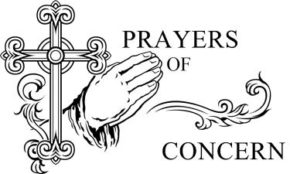IN OUR PRAYERS OF CONCERN PLEASE INCLUDE:**  Pete Schmidt, Ruth Wallerstedt, Marlice Sebade, Janice Johnson, Vernelle Nelson,Kyle Brand, Bill Dix,Fauniel Paulson, Allen Schrock, Charlie Ray, Gina Culbertson, Robert Johnson, Joel Paulson,Tim Dame**,** Connie Peterson, Rich Tomasek, Oliver Nimmo, Delwin Benne, Joseph Vandry, Landon Johnson, Gene Hansen, Gail Elsasser, Grace Meints, The Family of VerLee Wickstrom, Thad Nelson serving in Kuwait and all of our servicemen and women, our shut-ins and our youth ministry.



**January 2015 Ushers**

4th - Job Egbers, Roger Moderow, Loren Swanson and Eric Miller

11th – Jim Nelson, Norm Case, Tom Meyer and Jerry Benne

18th – Harley Nelson, Norm Case, Carl & Ian Lundquist and Larry Johnson

25th – Clare Wiltse, Norm Case, Tim Magnusson and Tom Mallette





**January 2015 Greeters**

4th - Jean Swanson, Jessica and Nicole and Tara, Carson, Camryn Peyton and Paxton Miller.

11th - Phyllis Meyer and Linda Carlson

18th - Roxanne Lundquist and Tess, Jamie and Lyndsey Johnson

25th – Annie, Ellen, Nolan and Carolyn Magnusson and Sandra Mallette







Jan 4 - Selena Johnson Jan 4 Colton Thomsen

11 - Wyatt Seagren 11 -Selena Johnson

18 - Jamison Johnson 18 - Wyatt Seagren

25 - Jared Mulder 25 - Jamison Johnson

Feb 1 Brady Jorgensen Feb 1 - Jared Mulder

**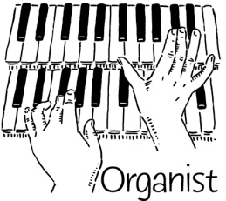**

4th - Dan Tanksley

11th - Tess Johnson

18th - Jim Pelan

25th - Jim/Dan

1st – Dan Tanksley

4th – Bryan Bohn

11th – Billye Pearson

18th - Bryan Bohn

25th - Bryan Bohn

**Thank you for your help in these important areas. If you can't be here, please find someone to take your place.**

****

**January 2015 Special Days**   
  
Some of the special days celebrated in January are:

* New Year's Day — January 1, 2015
* Epiphany — January 6, 2015
* Martin Luther King Jr. Day — January 19, 2014



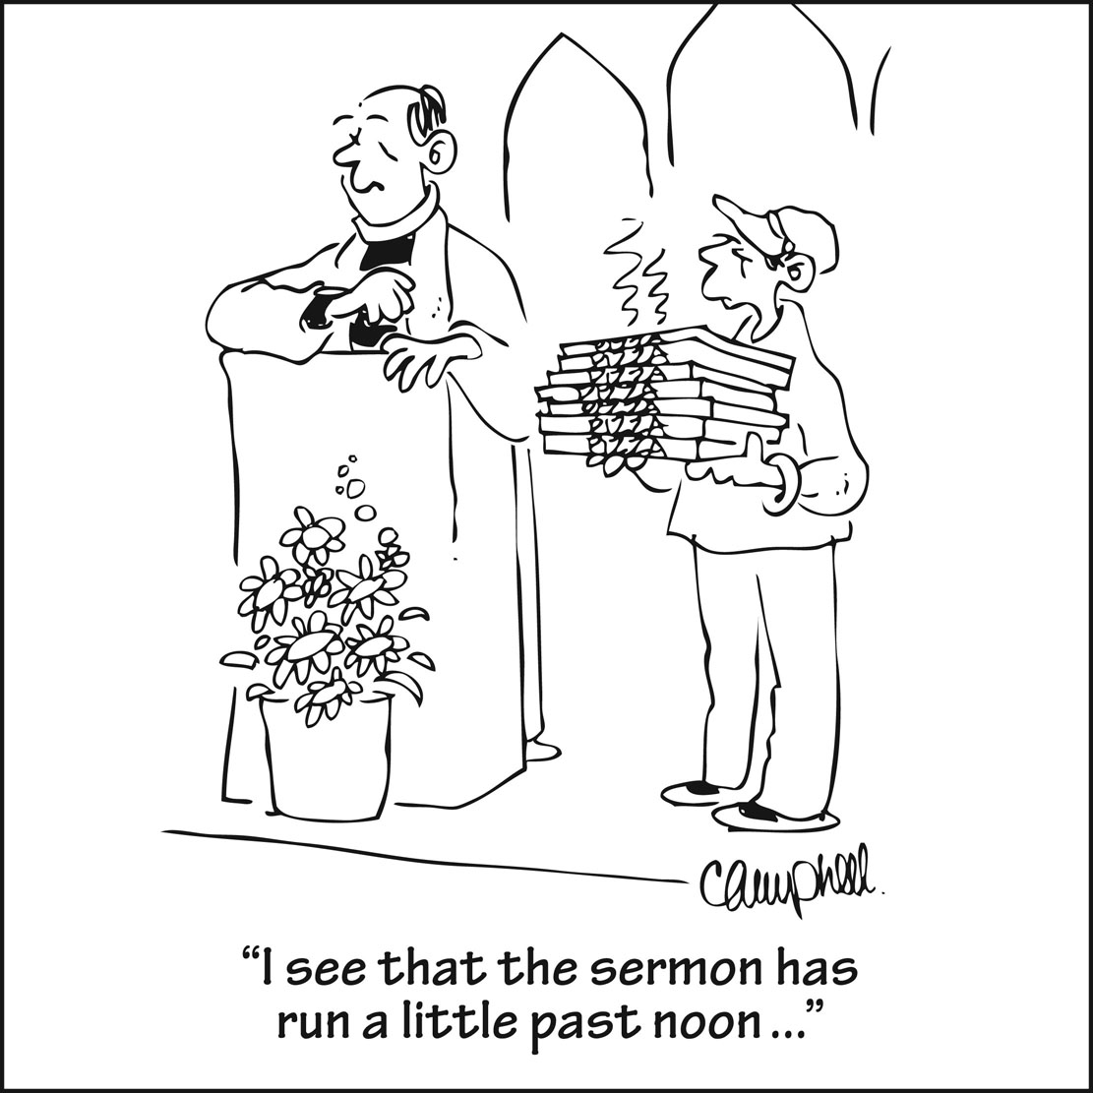

**FIRST EV. LUTHERAN CHURCH IS PART OF LCMC, Lutheran Congregations in Mission for Christ.**

***To find information regarding our synod –*** [***http://www.lcmc.net/***](http://www.lcmc.net/).

**CHRISTIAN HUMOR TO TICKLE YOUR LIFE**

*We’re on the Web!*

*Visit us at:*

www.firstlutheran-oakland.com

Friend us on Facebook

**We are committed to providing spiritual enrichment to ALL who seek the Lord.**

##### First Ev. Lutheran Church

PO Box 152, 201 N. Davis  
Oakland, NE 68045

##### Phone:

402-685-5764

##### Fax:

402-685-5183

##### E-Mail:

[firstlutheranchurch\_152@q.com](mailto:firstlutheranchurch_152@q.com)