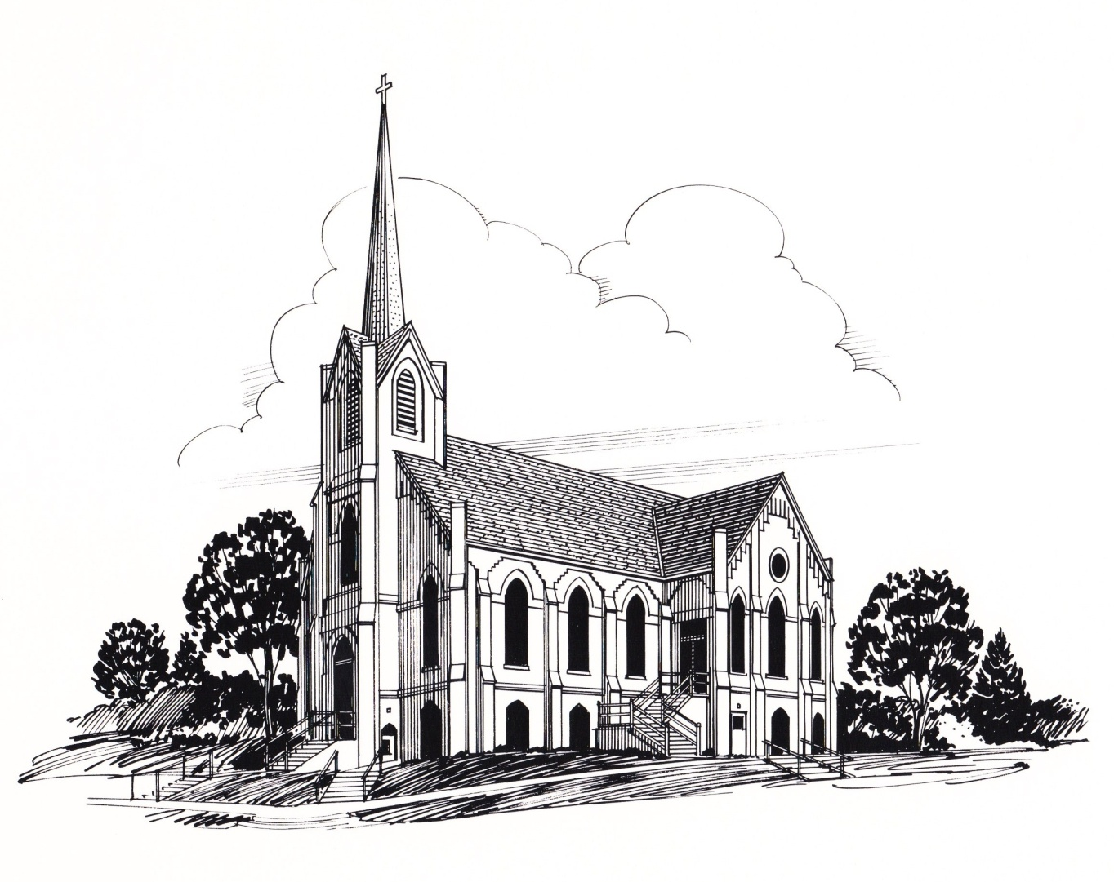

In John chapter one, John the Baptist introduces Jesus with the words, “Behold the Lamb of God who takes away the sin of the world.” As we journey thought this Lenten season perhaps there are no better words to remember than these words.
For we remember at this time of year how Jesus would come humbly as a lamb to die for you and me. Even though he was and is King of kings and Lord of lords he would willing lay down his life for us and then be raised on Easter morning.
He would do all of this so we might be forgiven and have eternal life.
This Lenten season may we live in loving awe of the Lamb who would give his life for us and then defeat death for us, and may we freshly claim the forgiveness and promise of eternal life he gives as we trust in him as our Savior.

God bless,

Pastor Mark

Inside This Issue
Pastor’s Column 1
Announcements 2
Lenten Servers and Sermon Series 3
Altar Committee & Sewing 3
W.O.W. & Dorcas Society, 4
Prayers of Concern 4
Birthdays and Anniversaries 5
Sunday School 5
The Calendar 6
Annual Meeting Minutes 7
Church Council Minutes 8
2015 Church Committees 10
Ushers, Greeters, Acolytes, 11
Video, Sound & Organists 11
Coffee Servers 11
Christian Humor 12

March 2015 Special Days
Some of the special days celebrated in March are:
- World Day of Prayer — March 6
- Girl Scout Sunday — March 8
- Daylight-Saving Time begins — March 8
- St. Patrick's Day — March 17
- First Day of Spring — March 20
- Palm Sunday — March 29

First Ev. Lutheran Church,201 N. Davis, PO Box 152 ,Oakland, NE, 68045

www.firstlutheranchurch-oakland.com, firstlutheranchurch_152@q.com

(402) 685-5764
By Rev. Mark Eldal

March 2015
Volume 3, Issue 3

THE SPIRE

ANNOUNCEMENTS

WORLD DAY OF PRAYER SERVICE will be at First Ev. Lutheran Church on Friday, March 6 at 2:00 p.m. there will be coffee and refreshments to follow.

On Wednesday nights through Lent, we will be conducting Lenten Services at 6:30 p.m. with a meal to follow. Everyone welcome!

DAYLIGHT SAVINGS TIME BEGINS MARCH 8, 2015
During Lent, on Friday mornings, Men's Lenten Prayer Breakfast are being held at the city auditorium from 6:00 a.m. – 7:30 pm.
There is a card shower for: Jean Richards – she turned 89
on February 24th. Please send cards to help her celebrate to:
1638 Harwood, Lincoln, NE 68502.
Happy Birthday Jean!!! WOW!

Winter Coat Drive. The Women of the Word (WOW) are planning a winter coats, mittens, and hats drive. We are going to try to keep these items in the area as there is a desperate need here. Please bring all gently used coats in any size, hats and mittens or gloves.
The offering envelopes for the 2015 year are located in the multipurpose room, please take them home with you.
Oakland Daisy Girl Scouts will be selling cookies. If you would like to order cookies Myesha Fields, Piper Tanksley and Madeline Pearson are selling them or you can contact Alana at 402-380-4552. They will be selling them around town at different locations, please watch the announcements on your Bulletin and Spire for more information coming...

We welcomed into membership BENTLEY MAE OLSON through holy baptism on Saturday Evening, February 28, 2015 at First Evangelical Lutheran Church. Her parents are Paula and Clay Olson. Her sponsors are Holly and Brian Tietz, Rylee Stevenson and Lee Morris. Bentley was born June 2, 2014. WELCOME BENTLEY!!
We welcomed into membership SCARLETT ANN JOHNSON through holy baptism on Sunday Morning, February 15, 2015 at First Evangelical Lutheran Church. Her parents are Dillon and Kelli Johnson. Her sponsors are Terry & Heather Zessin and Chad and Elisabeth Linder. Scarlett was born November 3, 2014. Her grandparents are Terry & Julie Johnson and Lennie & Dori Zessin. WELCOME SCARLETT!!
Please join us for Lenten Services starting Feb 25 @ 6:30 p.m. (Luncheon will be served afterwards.)
LENTEN SERVERS
Feb 25- Lenten Services—Executive WOW Group Serves
* March 4 -Lenten Services—New Group serves
March 11 -Lenten Services—Hannah serves
March 18 -Lenten Services—Mary serves
March 25 -Lenten Services— Ruth serves
*These may be different than what was listed in your WOW Booklets.

Lenten Sermon Series

Previews of Grace

Join us as we examine the lives of four Old Testament Characters and see God’s grace in their lives.

- Week One- Eve- Biting into a Bad “Apple”- Then Grace

- Week Two- Samson- Having a Bad Hair Day- Then Grace

- Week Three- Naomi- Just Call Me “Mud”- Then Grace

- Week Four- Jonah- Becoming Fish Bait- Then Grace

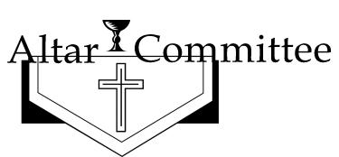
ELAINE PETERSON and JULIE EASTON

SEWING MEETINGS EVERY MONDAY AND TUESDAY MORNINGS
8:30 a.m. -12:00 p.m.
March 4.......Bingo @ O.H. 9:30 a.m………….Ruth
Lenten Services - 6:30 pm —New Group serves
March 6.......World Day of Prayer
@ 1st Ev. Lutheran Church 2 p.m.
March 9.......Executive Meeting 9 a.m.
March 11.....Group Meetings 9 AM, 2 PM,
Short meeting for Ruth Group after Lenten Church service
......Lenten Services- 6:30 pm —Hannah serves
March 19......Lenten Services- 6:30 pm —Mary serves
March 26......Lenten Services- 6:30 pm —Ruth serves
March 29......Palm Sunday
March 30-April 3......Holy Week
Clean Kitchen ........Mary

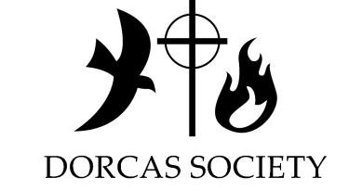
Dorcas Society March 25 @ 2:00 p.m.
@ Oakland Heights

PRAYERS OF CONCERN
IN OUR PRAYERS OF CONCERN PLEASE INCLUDE: Donna Larson, Gary Rosenboom, Kaylee Fajan (Judee Dix's Granddaughter), Bob Wonka, Bill Taylor, Pete Schmidt, Vernelle Nelson, Ruth Wallerstedt, Marlice Sebade, Kyle Brand, Bill Dix, Fauniel Paulson, Allen Schrock, Charlie Ray, Robert Johnson, Rich Tomasek, Oliver Nimmo, Delwin Benne, Joseph Vandry, Landon Johnson, Gene Hansen, Gail Elsasser, Grace Meints, Thad Nelson serving in Kuwait and all of our servicemen and women, our shut-ins and our youth ministry.

MARCH BIRTHDAYS

1 – Teresa Egbers, Cynthia Johnson, Eric Miller, Mollie Kate Blanc
2 – Nancy Wonka
3 –James Unwin, Ruth Wallerstedt
5 – Ron Brudigam
7 – James Unwin
8 – Spencer Bromm
9 – Heath Anderson
10 – Connie Anderson, Julie Jones
11 – Teigan Case, Rylee Stevenson
13 – Alexis VonEssen
14 – Russell Peterson, Laura Schnoor
15 – Scott Krutilek
16 – Scott Lindstrom, Earl Miller, Susie Nelson
17 – Lee Peterson
18 – Jeff Nelson
19 – Donald Andersen, Baker Blanc
20 – Marlene Lindstrom, Linda VonEssen
MARCH’S ANNIVERSARIES

7 – Jay & Diane Lindstrom
12 – Richard & Marcee Tomasek
18 – Merle & Karen Karstens
27 – Mike & Janna Kloth
31 – Charles & Betty Rogers

21 – Mike Denton
22 – Dolores Bailey, Bonnie Goodrich, Vern Jensen
23 – Delwin Benne
24 – Roger Maller
25 – Dexter VonEssen, Don Wallace
26 – Connor Guill, Kent Johnson, Richard Strom, Henry Unwin
27 – JoAnna Lierman
28 – Mary Alice Pearson
29 – William Akingnbade, Cheryl Denker, Don Wolf
30 – LeighAnn Blomenkamp, Richard Mulder, Eric Easton, Mallory Blanc
31 – Judy Troupe

** Please note - Due to the hard drive crashing on the office computer some data was lost. If you have noticed that your birthday is not being listed in The Spire and you would like it listed, please contact Tess in the office.

Our kids will sing on March 8th and Palm Sunday – March 29th and on that day our 3rd graders will also get their bible!

"Give thanks to the LORD, for he is good; his love endures forever." 1 Chronicles 16:34

March 2015
Sun | Mon | Tue | Wed | Thu | Fri | Sat
1 | 2 | 3 | 4 | 5 | 6 | 7
9:30AM COMMUNION SERVICE  10:30AM FELLOWSHIP AND SUNDAY SCHOOL  11:00AM BIBLE STUDY | 8:30AM SEWING GROUP  7:00PM CHURCH COUNCIL MEETINGS | 8:30AM SEWING GROUP | 9AM MEN'S BIBLE STUDY  9:30AM BINGO @ OAKLAND HEIGHTS  6:30PM LENTEN SERVICES  7:15PM - 9:00 P.M CONFIRMATION  8:00 PM CHOIR PRACTICE | 8:00 PM N.A. MEETINGS |  | 5:30PM WORSHIP SERVICE
8 | 9 | 10 | 11 | 12 | 13 | 14
9:30AM WORSHIP SERVICE  10:30AM FELLOWSHIP AND SUNDAY SCHOOL  11:00 AM BIBLE STUDY | 8:30AM SEWING GROUP  4:00 PM WOW EXEC MEETING | 8:30AM SEWING GROUP | 9AM 2 PM, GROUP MEETINGS  6:30PM LENTEN SERVICES  7:15PM - 9:00 P.M CONFIRMATION  8:00 PM CHOIR PRACTICE | 8:00 PM N.A. MEETINGS |  | 5:30PM WORSHIP SERVICE
15 | 16 | 17 | 18 | 19 | 20 | 21
9:30AM CONTEMPORARY SERVICE  10:30AM FELLOWSHIP AND SUNDAY SCHOOL  11:00 AM BIBLE STUDY  6:00 PM KOINONIA MEETING | 8:30AM SEWING GROUP | 8:30AM SEWING GROUP  ST. PATRICK'S DAY | 6:30PM LENTEN SERVICES  7:15PM - 9:00 P.M CONFIRMATION  8:00 PM CHOIR PRACTICE | 8:00 PM N.A. MEETINGS |  | 5:30PM WORSHIP SERVICE
22 | 23 | 24 | 25 | 26 | 27 | 28
9:30AM WORSHIP SERVICE  10:30AM FELLOWSHIP AND SUNDAY SCHOOL  11:00 AM BIBLE STUDY | 8:30AM SEWING GROUP | 8:30AM SEWING GROUP | 2:00 PM DORCAS SOCIETY @ O.H.  6:30PM LENTEN SERVICES  7:15PM - 9:00 P.M CONFIRMATION  8:00 PM CHOIR PRACTICE | 8:00 PM N.A. MEETINGS |  | 5:30PM WORSHIP SERVICE
29 | 30 | 31
10:30AM FELLOWSHIP AND SUNDAY SCHOOL  11:00 AM BIBLE STUDY | 8:30AM SEWING GROUP | 8:30AM SEWING GROUP
(CORRECTION FROM FEBRUARY SPIRE)
First Evangelical Lutheran Church
Oakland, Nebraska
Annual Meeting
January 25, 2015

The annual meeting of the congregation of First Evangelical Lutheran Church was held January 25, 2015. A quorum was met with 68 members present.

After devotions were given by Pastor Mark, the meeting was called to order by Vice President, Roger Moderow, who presided in the absence of President, Cheryl Denker. The following board members were present: Roger Moderow, Mona Tanksley, Jan Wiltse, Sandy Husar, Rachel Wise, Greg Ray, Kylie Penke, Jim Pelan, Carl Magnusson and James Schrock.

The minutes of the 2014 meeting were read by Mona Tanksley. A motion was made by Darrell Denker to approve them. Motion seconded by Mike Blanc, a vote taken and motion carried.

The Nominating Committee report was presented by Darrell Denker, who reported that five nominees are on the ballot with four to be elected to a three year term on the church council. They are Kylie Penke, Mona Tanksley, Tom Meyer, Sam Schmidt and Greg Johnson. As there were no nominations from the floor, a motion was made by Darrell Denker, seconded by Jim Nelson that nominations for church council cease. A vote was taken and motion carried. Nominees for the Outreach Committee included Norm Case, James Unwin and Mike Blanc. Two will be elected to positions on this committee. Again there were no nominations from the floor and a motion was made by Darrell Denker that nominations cease. Motion seconded by Jim Nelson, a vote taken and motion carried.

The Auditing Committee report was given by Greg Ray who reported that after auditing the books everything was found to be in good order. A motion was made by Joan Johnson to accept this report. Motion was seconded by Candace Johnson, a vote taken and motion carried.

Reports:
- Pastor Eldal gave his report and there were no questions or comments.
- Roger Moderow gave the Church Council report highlighting activities and events of the last year.
- The Pastoral Acts and statistical reports were reviewed.
- The Outreach Committee report was given by James Unwin who noted that there is $26,488.68 to be distributed to the areas that have been decided upon by the committee. After discussion, a motion was made by Bonnie Goodrich to accept the report. Motion was seconded by Kent Johnson, voted upon and carried.
- The Financial Secretary and Treasurer’s report was given by Audrey Unwin who explained how items are categorized. She also explained the Fund Report answering questions that arose. A motion to accept these reports was made by Charlie Seagren and seconded by Beverly Peterson. A vote was taken and carried.
- Women of the Word report no comments.
- Property Committee report, no comments.
- Worship Committee report, no comments
- Dorcas Society report, no comments
- Altar Committee report, no comments
- Funeral Luncheon Committee report, no comments
- Sunday School Teachers/Vacation Bible School reports reviewed. A thank you was given to Jill, Cindy and all the teachers who have helped to make this a great year for our Sunday School children. Thanks was also given to Alissa Bousquet for her work coordinating VBS.
- Evangelism Committee report, no comments.

Old Business: There was no old business to discuss.

New Business: Roger Moderow reported that the Mission Benevolence Fund had not been discussed at the last council meeting. The missions supported in 2014 were LCMC, Oakland Ministerial Association, Oakland Food Bank, Dr. Stuart Embury’s ministry to Haiti and Lutheran Family Services. After discussion, a motion was made by Charlie Seagren to support these same five organizations this year with each receiving an equal share of the money. Motion was seconded by Carl Magnusson. A vote was taken and motion carried.

The proposed budget for 2015 was reviewed. Questions were answered by Greg Ray and after discussion a motion was made by Jim Nelson to accept the budget. Motion seconded by Mike Blanc. A vote was taken and motion carried.

Roger Moderow reported the results of the election noting the following were elected to the church council: Kylie Penke, Mona Tanksley, Sam Schmidt and Greg Johnson. The two elected to the Outreach Committee were Norm Case and James Unwin.

Beverly Peterson expressed thanks to the funeral luncheon committee for their service to the church and to the families who have lost loved ones.

An offering was taken that will be given to Dr. Embury’s Haiti ministry.

There being no further business, a motion was made by Jim Nelson to adjourn the meeting. Motion seconded by Ed Anderson, a vote taken with the motion carried.

The meeting adjourned with Pastor Mark leading us in the Lord’s Prayer.

Respectfully,
Mona Tanksley, Secretary

First Evangelical Lutheran Church
Oakland, Nebraska

The church council met February 2, 2015 at 7:00 p.m. In attendance were Cheryl Denker, Kylie Penke, Sam Schmidt, Greg Johnson, Rachel Wise, Jim Pelan, Jan Wiltse, Jon Seagren, Roger Moderow, Carl Magnusson, Mona Tanksley and Pastor Eldal.

Roger Moderow opened the meeting with devotions followed by election of officers. A motion was made by Carl Magnusson casting a unanimous ballot to keep all three officers we presently have, those being Cheryl Denker, President, Roger Moderow, Vice President and Mona Tanksley, Secretary. Motion seconded by Rachel Wise and carried. All council members signed up for committees on which they would like to serve. A list of the committee chairmen will be published in the Spire so members will know who to contact if questions arise pertaining to activities of a specific committee.

Pastor presented his report for the month of January.

The minutes of the previous meeting were read and a motion was made by Jon, seconded by Kylie to accept the minutes. Motion carried.

Evangelism and Financial Committee: Rachel reported that Audrey Unwin, has the exact figures on how much is still owed on the parking lot. We discussed having a demo of the website shown on the screen some Sunday so all members can become familiar with it.

Property Committee: Items addressed were air leaks in the sanctuary windows, excess heat in the secretary’s office, the fence blocking circulation around the air conditioner, the uneven concrete that will be ground down north of the ramp. We discussed the idea of remodeling the multipurpose room to install a counter with a coffee bar. We will obtain more information on details of what our options would be in addition to getting information about a coffee machine. Also discussed was installing some type of flooring in the room downstairs where carpet was removed after rain water came in. This will be decided after we are sure there is no longer a problem with leakage. We discussed ideas of a room where the youth can meet for Sunday school.

Old Business: We discussed the idea of having sign-up sheets available for people who are willing to assist with activities in the church in an effort to make the job of calling easier for those involved. We could possibly use the website as a sign up area also. Roger discussed the need for additional head ushers. He will compile a list of duties of these ushers and offered to meet with them so all are aware of what is involved. Cheryl and Mona will review the list of members to help insure the list is up to date. Cheryl thanked all who helped with the annual meeting. We discussed having Audrey Unwin attend a council meeting early in the year to explain the financial reports to council members, especially to educate those newly elected. We also would like Jim Unwin to come and explain the Outreach fund so we are familiar with it.

New Business: Information has been received about a church camp that will come and do the Bible School. As the cost is about the same, it was decided that we will go ahead with having them come. Since the youth is leading the service on Sunday, Feb. 8 when Pastor is gone, any council members available to assist with the sub sandwiches that day are welcome. The next communion will be Ash Wednesday and Cheryl offered to assist with it. It was reported that the small group Bible study during Lent will be in conjunction with the services. Lastly we discussed evangelism and ways to make the church grow, be it small groups, Bible studies, etc.

Communion Helpers February 28 – Arla Ogden, March 1 – Mona Tanksley

Devotions for March 2 meeting – Kylie Penke

The meeting adjourned with all saying the Lords Prayer.

Respectfully,
Mona Tanksley, Secretary

February Finances
Commitments $9,624.00
Building Use $ 51.00
Initial Offering $ 125.00
Ash Wednesday $ 997.00
Sunday School $ 30.05
Misc $ 538.64
Total $11,365.69
February
Attendance
31&1(No Church - Blizzard) 30
7 & 8……………… 185
15 & 16…………… 196
18 (Ash Wed) … 96
22 & 23…………… 164

January Finances
Commitments $15,255.83
Initial Offering $ 165.00
Designated $ 208.00
Sunday School $ 8.92
Memorial $-
Misc $ 703.25
Total $16,341.00
January
Attendance
3 & 4………… 113 10 & 11……… 199
17 & 18……… 174
24 & 25……… 145

2015 FIRST EVANGELICAL LUTHERAN CHURCH COMMITTEES

PROPERTY COMMITTEE: Norm Wallerstedt, Ed Anderson, Darrell Denker, Dan Tanksley and Don Johnson Sam Schmidt, Jon Seagren, and Greg Johnson;
CHAIRMAN…Jim Pelan 685-4062
FINANCE COMMITTEE: James Schrock, Dr. James Unwin, Julie Jones, Tim Magnusson, Greg Johnson, and Carl Magnusson;
CHAIRMAN…Jon Seagren 685-5276
EDUCATION COMMITTEE: Angie Rennerfeldt, Delaney Brudigam, Sandy Husar and Roger Moderow;
CHAIRMAN…Kiley Penke 377-1657
WORSHIP COMMITTEE: Sara Wallace Judy Nelson Betty Hanna Sandra Johnson, Beverly Peterson, Patty Miller, Sandy Husar and Jan Wiltse;
CHAIRMAN…Mona Tanksley 685-5382
EVANGELICAL COMMITTEE: Nancy Johnson, Jan Wiltse and Kiley Penke; CHAIRMAN…Rachel Wise 685-5949
AUDIT COMMITTEE: Patty Moderow, Don Johnson, Jim Pelan;
CHAIRMAN...Roger Moderow 685-6275
FUTURE PLANNING COMMITTEE: Dr. James Unwin, Jill Johnson, Melinda Johnson, Bonnie Goodrich;
CHAIRMAN…Carl Magnusson 685-5797
If you see an issue which needs to be addressed, please contact a chairman from the group corresponding to the problem. Thank you!!

March 2015 Ushers
1st:Job Egbers, Roger Moderow, Sam Schmidt and Luke Blanc
4th Roger Moderow, Jarod Mulder and Ian Lundquist
8th :Jim Nelson, Norm Case, Calvin Moseman and Clay Olson
11th Norm Case, Lane Peterson and Gavin Saxton
15th:Norm Case, Charlie Seagren, Mark Peterson and Lane Peterson
18th Charlie Seagren, Garrison Dodge and Wyatt Seagren
22nd: Norm Case, Clare Wiltse, David Pearson and Garrett Pearson
25th Clare Wiltse, Braden Case and Josh Deemer
29th:Norm Case, Jason Penke and Lee Peterson

March 2015 Greeters
Mar 1st: Selena Johnson,Jamie Johnson, Ashley Denton and Zoe Linder
Mar 8th: Marion Moseman and Susan Moseman
Mar 15th:Jodi, Johnna and Kara Peterson and Arla Ogden
Mar 22nd:Kathy Pearson and Mary Alice Pearson
Mar 29th:Kiley, Tate and Tye Penke and Sharon Peterson

1 &4 - Katie Miller 1 &4 -Garrison Dodge
8 &11 - Jacob Deemer 8 &11 - Katie Miller
15 &18 - Jared Krutilek 15 &18 -Jacob Deemer
22 & 25 - Megan Bousquet 22 & 25 - Jared Krutilek
29 & Apr 2 - Lane Peterson 29 & Apr 2-Megan Bousquet
Apr 3 & 5 - Ian Lundquist Apr 3 & 5 - Lane Peterson

1 – Dan Tanksley
4 – Tess Johnson
8 - Tess Johnson
11 - Tess Johnson
15 - Jim/Dan
18 - Tess Johnson
22 - Jim Pelan
25 - Tess Johnson
29 - Dan Tanksley

1 – Bryan Bohn
4 – Bryan Bohn
8 - Billye Pearson
11 - Bryan Bohn
15 - Ruth Wallerstedt
18 - Bryan Bohn
22 -
25 - Bryan Bohn
29-

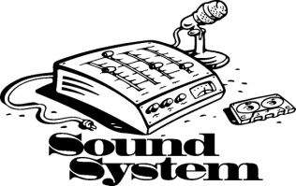

Coffee Servers Coordinators Date of Service

Julie Easton, Teresa Egbers, Tess Johnson Sunday, March 01,2015
Jacque Eldal, Linda Carlson, Cheryl Denker Sunday, March 08,2015
Judy Groene, Lela Heineman, Jan Wiltse Sunday, March 15,2015
Amanda Huntington, Sandy Husar, Patty Miller Sunday, March 22,2015
Kelli Johnson, Candace Johnson, Tess Johnson Sunday, March 29,2015
Carole Johnson, Sandra Johnson, Tess Johnson Sunday, April 05, 2015

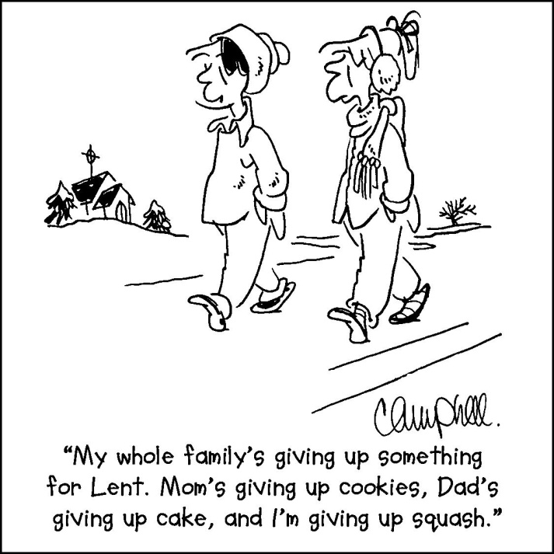
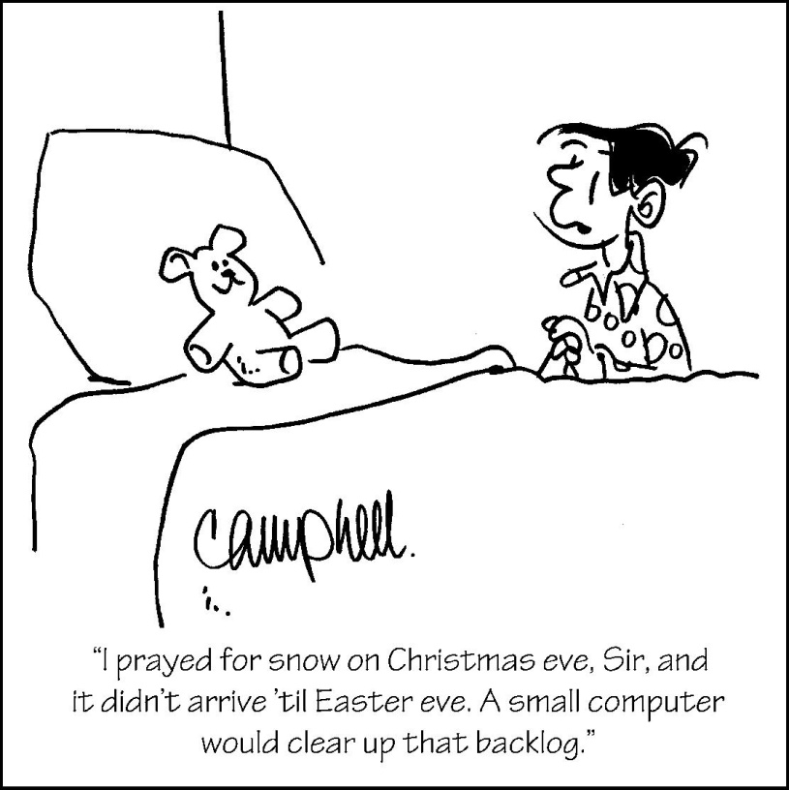
CHRISTIAN HUMOR TO TICKLE YOUR LIFE

We are committed to providing spiritual enrichment to ALL who seek the Lord.

We’re on the Web!
Visit us at:
www.firstlutheran-oakland.com

First Ev. Lutheran Church
PO Box 152, 201 N. Davis
Oakland, NE 68045

Phone:
402-685-5764

Fax:
402-685-5183

E-Mail:
firstlutheranchurch_152@q.com

2015
Mar 4, 11, 18, 25 – 6:30 PM Lenten Services

